Halsey Street Commons Redevelopment Plan

Prepared by Theo Mackey Pollack

For the Mayor and Municipal Council of
The City of Newark, N.J.

June 1, 2010
Contents

I: Overview of the Plan 2
Introduction 2
Statutory Basis of the Plan 3
Purpose of the Plan 3
Defined Terms 6
II: Diagrams & Illustrations 12
The Area in the Context of the Region 12
The Area in the Context of the Neighborhood 12
Boundaries of the Area, Showing Blocks & Lots 13
Susceptibility to Change 14
Existing Buildings 2010 15
Abandoned, Contaminated, and/or Disused
Commercial Buildings 16
Paved Parking Lots 16
Massing Model 17
Land Use Map 18
III: Land Use Regulating Plan 18
Application to Existing Uses 18
Permitted Uses 19
Prohibited Uses 22
IV: Mobility Plan 23
Transit 25
Pedestrian Realm 26
Thoroughfare Specification 27
Loading and Disposal Regulations 30
V: Building Regulating Plan 31
Building Heights 31
Build-to lines 33
Architectural Regulations 34
VI: Landscape Plan 44
Individual Site Plans for Private Parcels 45
General Hardscape Requirements 46
General Planting Requirements 49
Schedule of Recommended Trees 51
Outdoor Lighting Specifications 52
Street Furniture Requirements 53
The Commons and Arcade 54
VII: Parking and Utilities Plan 57
Parking Demand 57
Parking Structures 58
Metered Street Parking 60
Additional Parking Requirements 60
General Utility Requirements 61
VIII: Legal Provisions 62
I: Overview of the Plan

(a) Introduction

The Halsey Street Commons Redevelopment Plan (hereafter, “the Plan”) seeks to transform the character of several key blocks in downtown Newark, New Jersey. The Plan is not a proposal for radical change, but instead seeks to recover certain essential elements of the Halsey Street Commons Redevelopment Area’s (“the Area”, replacing, “the Study Area”) historical character, and to express these qualities in the context of high-quality renovation and complementary new development. The overarching goal of the Plan is to weave together a collection of presently-disused, neglected, and blighted parcels, in such a manner that their new cohesion will emerge seamlessly from the city’s historic fabric of streets, buildings, and neighborhoods. Upon completion, the Plan will provide new opportunities for housing, shopping, business, relaxation, and entertainment, as well as outdoor recreation in an assortment of high-quality public spaces. Of equal importance, the Plan will also help foster the Area’s development into a springboard for the recovery of adjacent blocks in downtown Newark.

The Area straddles an historical boundary at the western edge of Newark’s commercial core, where the bustling central business district (CBD) gives way to a series of quieter blocks that have long been dedicated to academic, residential, and small-scale retail uses. This transition is one essential element that the Plan seeks to restate. Presently, the prevalence of surface parking fields in the Area has eroded the physical clarity of this transition. The Plan seeks to reframe the transitional nature of the Area, balancing a higher intensity of development along Broad Street with more neighborhood-scale buildings along Halsey and Washington Streets. Therefore, rather than expanding the CBD’s intense footprint westward, the Plan seeks to foster the first truly viable, mixed-use, residential neighborhood in proximity to the CBD. It achieves this by maintaining the historical scale of the Area’s development pattern, while capitalizing on its proximity to the transportation and commercial offerings of the adjacent CBD.

The Plan seeks to build on sustainable development principles, taking into consideration the future of the city’s economy, ecology, and social equity. First, by requiring efficient land use, another essential element of the neighborhood’s historical development pattern, the Plan seeks to foster an Area that becomes an economic engine of the city, capitalizing on its density and proximity to spur new commerce and maximize the value of downtown Newark’s urban land. Second, by refocusing development on a walkable grid, and by taking advantage of proximity to Newark’s extensive mass transit facilities, the Plan seeks to encourage a more ecological approach to new housing, which reduces the carbon footprint of its residents and offers an alternative to land-wasting, suburban greenfields development. In the same vein, the Plan strongly encourages the use of environmentally-sensitive building design, green rooftops, ample open space, and high-quality, durable materials, which can be permanently maintained, rather than perennially replaced. Finally, by making provisions for a significant new stock of affordable housing units, and by providing these units in close proximity to the city’s employment, academic, and transportation centers, the Plan seeks to foster a truly equitable approach to urban housing that provides for the needs of a diverse population within a single, compact community.

The Plan uses information produced by an extensive survey of the current and historical conditions in the Area, and it draws on a number of key principles espoused by the Congress for the New Urbanism (CNU). The result is a vision for a new neighborhood, built on the ashes of disuse, neglect, and blight, which recovers the most practical essential elements of the city’s past, while readily embracing innovation and progress, with an eye toward a sustainable future.

(b) Statutory Basis of the Plan

The Municipal Council for the City of Newark, by way of Council Resolution 09-201, adopted by a unanimous vote on 1 February, 2009, authorized the Department of Planning and Community Development (DPCD), and any contractors to whom it might assign its statutorily-conferred responsibility, to do the following:

1. Undertake a preliminary investigation, pursuant to the notice, hearing, and other requirements of the Local Redevelopment and Housing Law, N.J.S.A. 40A:12A-1, et seq., of an area to be known as the Halsey Street Commons Study Area, (hereinafter the Study Area) to determine whether or not this Study Area meets the statutory criteria necessary to be declared an “Area in Need of Redevelopment” as outlined in NJSA 40A:12A-5 and NJSA 40A:12A-6; and

2. Propose a Redevelopment Plan for this Study Area if it is found to be in Need of Redevelopment.

(c) Purpose of the Plan

The purpose of the Plan is to establish a formal set of conditions under which the Halsey Street Commons Redevelopment Area may be redeveloped by a designated group of Redevelopers. In accordance with this purpose, the Plan sets forth the formal and aesthetic requirements and recommendations for the Area. Specifically, the Land Use section describes the mandatory and recommended uses for each component parcel; the Mobility section describes the layout of streets and their respective traffic patterns; the Building Regulations describe the general massing and height limitations of new buildings and the requisite design criteria for new buildings; the Landscape section describes the open space and streetscape design elements; and the Parking and Utilities section addresses the specific guidelines for those matters.

The physical components of the Plan are both written and illustrated using a form-based code. This type of code is the most effective approach for assuring the highest standards of implementation for the Area’s urban design. It ensures that the Redevelopment Agency (RA) can expect contractors to meet standards of superior quality that will complement and enhance the existing character of the City and have a long-term positive fiscal and aesthetic impact on the residents and businesses of Newark. It further assures a high level of market flexibility to assure that the Redeveloper can build and market a superior product that is financially feasible, while maintaining architectural design flexibility within an urban context.

The Halsey Street Commons Redevelopment Plan seeks to recover the traditional fabric of a series of blocks in downtown Newark, while promoting sustainable urban design that includes measures supporting the economy, ecology, and social equity of the city. When completed, the Plan will add housing, shopping, restaurants, taverns, and new public spaces, while serving as a new locus for the cohesive development of the surrounding areas.

(i) Overview of the Plan

Floor areas are calculated by measuring the total square-footage of all the Area’s floors which are dedicated to a particular use, and discounting these figures by 15 percent to account for utility rooms, elevator shafts, hallways, stairwells, common areas, and other exclusions. While residential and office space may ultimately be substitutable, depending on market demands, the figures below assume a 3:1 ratio of residential to office space for future development of the Area’s total upper floors. Existing space figures are based on 2010 land uses for each parcel in the Area.

 | Retained Existing  Space | Proposed  Space – New Construction | Proposed Area Total
Residential | 139,619 | 833,315 | 972,934
Office | 46,539 | 277,772 | 324,311
Retail | 63,120 | 97,164 | 160,284

(ii) Redevelopment Goals

By adoption of the Plan, the City of Newark seeks to accomplish the following goals:

(a) Eliminate underutilization, neglect, and blight within the Area.

(b) Recover the historical fabric of the Area’s share of Newark’s downtown street grid, through the development of buildings, blocks, and, ultimately, a neighborhood that makes productive use of the Area’s presently underutilized or blighted land parcels.
(c) Draw on the Radburn principle of the distinct pedestrian realm, with the creation of two fully-functional, automobile-free commons, in conjunction with complementary plazas and arcades, which encourage walking, bicycling, outdoor recreation, and face-to-face interaction, in a space that is physically apart from the noise, danger, and pollution of constant motor-vehicle traffic.

(d) Maximize the advantages provided for the Area by its proximity to the Newark Light Rail (NLR), the Port Authority Trans-Hudson (PATH), and the commuter railroad lines operated by New Jersey Transit (NJT), by developing a mixed-use, walkable neighborhood that capitalizes on these resources in accordance with the best principles of transit-oriented development (TOD).

(e) Practice sustainable development while expanding the City’s tax base in the Area. Increase the efficiency of urban land use, thereby increasing the number of ratables on the City’s tax rolls; improve the Area’s land values through high-quality, mixed-use development; and raise the overall levels of economic productivity in the Area.

(f) Apply the best principles of New Urbanism by incorporating the tried traditions of town planning practice regarding building scale, land use, and aesthetics; and by fostering the creation of a diverse, equitable, and abiding neighborhood, whose physical design is sufficient to accommodate the needs and wishes of such a community.

The goals set forth herein are intended to be broad, general policy statements. While specific aspects of the Plan may result in some variation or deviations from these goals, it is intended that the overall result of the Plan’s implementation will be strongly consistent with the goals set forth above.

(iii) Redevelopment Objectives

The Plan is prepared in response to the Department of Planning and Community Development’s determination that the Area meets the requisite criteria set forth by the Local Redevelopment and Housing Law, N.J.S.A. 40A:12A-1, et seq., and the Municipal Council’s request for the drafting of such a Plan, in light of that finding. The object of the Plan is to transform the designated Area into a more vital part of the City, and to foster an expansion of both social and economic activity therein. Pursuant to the requisite statutory criteria, the following objectives have been specifically established for the Plan:

a. The replacement of the unsafe, dilapidated, and/or abandoned commercial buildings at the southern and northern edges of the Area (specifically, the former S. Klein and Hahne buildings, respectively), with new, sustainable mixed-use residential and commercial projects. This aspect of the Plan is undertaken pursuant to criteria (a), (b), and (d) of New Jersey’s Local Redevelopment and Housing Law (LRHL).

b. The assembly of small and oddly-shaped publicly-owned parcels in the Area to create larger, more regular, more alienable or assignable parcels. This objective is undertaken pursuant to Section (c) of the LRHL.

c. The replacement of surface parking lots throughout the Area with new, sustainable, mixed-use residential and commercial projects; and the replacement of all surface parking with underground and embedded parking facilities, consistent with land use efficiency principles of New Urbanism. This aspect of the Plan is undertaken pursuant to criteria (e) of the LRHL.

d. Designation of the Area in a manner consistent with Smart Growth planning principles. This aspect of the plan is undertaken pursuant to criteria (h) of the LRHL.

(d) Defined Terms

The definitions provided for the terms below shall prevail within the scope of the Plan. For definitions not contained herein, the definitions contained in the Zoning Ordinance for the City of Newark shall prevail. The following definitions are provided as examples, and additional definitions may be added by addendum. Terms which have already been defined in the corresponding section of the Municipal Land Use Law need not be redefined here.

Area -The Halsey Street Commons Redevelopment Area, as defined by the official boundary drawn on the map below.

Block -The aggregate of one or more lots as circumscribed by thoroughfares.

Block Area – The total land area contained within a block, as measured within the front edge of the sidewalk, or from the actual lot line.

Block Face – The aggregate of all the building façades on one side of a block.

Brownfield – Any former or current commercial or industrial site that is currently vacant or underutilized and on which there has been, or there is suspected to have been, a discharge of a contaminant (NJSA: 58: 10B-23.d).

Build-to-line – A construction line at which the primary façade of a building must be located.

Buildable Area – The Block Area, minus the area of the public right-of-way (sidewalk). The buildable area includes the semi-public edge, where porticos, stoops, and fences may extend beyond the façade.

Building Frontage - The length of a façade along a public street.

Building Height - The vertical extent of a building, as measured from ground level.

Capacity – The maximum and/or minimum projected square footage of residential, retail, and/or office space.

Cartway - The paved area of a street, between the curbs, including travel lanes and parking areas but not including shoulders, curbs, sidewalks, or swales.

City – The city of Newark, New Jersey.

Context - A particular combination of elements, which create an urban setting.

Curb - The physical edge of the cartway, detailed as a raised masonry step.

Design Speed - The velocity at which a thoroughfare tends to be driven without the constraints of signage or enforcement, due to its lane width. There are four ranges of speed:
- Very Low (below 20 MPH)
- Low: (20-25 MPH)
- Moderate: (25-35 MPH)
- High (above 35 MPH)

Developable Area - The designated area, on a specific parcel, where a building may be located.

Development - The division of a parcel of land into two or more parcels; the construction, reconstruction, conversion, structural alteration, relocation, or enlargement of any building or other structure, or of any excavation or landfill; and any use or change in the use of any building or other structure, or land or extension of use of land, for which permission may be required pursuant to the “Municipal Land Use Law,” P.L. 1975, c.291 (C.40:55D-1 et seq.).

Elevation (Drawing) - A depiction of the exterior walls of a building or structure. An elevation includes material, rendered window and door openings, height and façade details.

Encroachment (Permitted) - A distance beyond the build-to-line to which certain building elements may protrude. Typically, a permitted encroachment is expressed in feet.

Façade – A vertical, exterior face of a building.

Floor Area – The sum of the area of all floors of a building, measured from the exterior face of the exterior walls, or from the centerlines of common walls separating two buildings. The measurement excludes the areas occupied by mechanical rooms, parking areas, elevators, escalators, and stairways.

Floor Area Ratio (FAR) - A ratio between the total floor area on a particular site, and the actual ground area of that site. Generally, the FAR is expressed as a single number.

Green Roof – A roof that is partially or completely covered with plants, and which may be used to retain storm water, to provide insulation, and/or for the recreation of tenants.

Height Limit – The maximum allowed height for a building on a particular parcel. Height limits do not apply to masts, belfries, clock towers, chimney flues, water tanks, elevator bulkheads, or similar structures. Heights shall be measured from the average finished grade of the fronting thoroughfares.

Identifiable Building Width (IBW) – The articulation of a boundary between the façades of adjoining buildings by a transition of texture, material, pattern, or other design elements.

Interim Use - A temporary use of land, permitted before the implementation of the ultimate goals of the Redevelopment Plan. Such a use is frequently an element of the phasing plan.

Mandatory Standards - Provisions and specifications with which compliance is required, rather than optional. Phrases or sentences that denote such provisions contain the words “require”, “must”, and “shall”.
Mixed-Use Building - A building which may be occupied by a variety of complementary uses, including, but not limited to, residential, office, retail, public, and/or entertainment spaces.

Non-Mandatory Provisions - Provisions and specifications with which compliance is encouraged, but not required. Phrases or sentences that denote such provisions include, but are not limited to, “may”, “should”, “recommended”, “encouraged”, “proposed”, “typical”, “allowed”, and “approximately”. Sometimes, these provisions are also referred to as Aspirational Standards.

Open Space - Any park, green space, public plaza, commons, courtyard, pedestrian mall, or similar area that is open and unobstructed from its lowest point to the sky.

Parking Space - An area not to exceed nine (9) feet in width or eighteen (18) feet in length (except handicapped spaces) whose intended use is for the parking of motor vehicles.

Plan - The Halsey Street Commons Redevelopment Plan.

Portico - A small porch, leading to a building entrance, with a roof supported by columns.

Property Line - The legal boundary which denotes the extent of a particular parcel of land, and the property rights which are appurtenant to that land. It is frequently marked by the edge of a right-of-way, block, and/or lot.

Public Realm - The full extent of spaces which are seen and used by members of the public.

Redeveloper - Any person, firm, corporation, or public body that shall enter into or propose to enter into a contract with a municipality or other redevelopment entity, for the purpose of redevelopment or rehabilitation of an area in need of redevelopment, or an area in need of rehabilitation, or any part thereof, under the provisions of the LRHL; or for any construction or other work forming part of a redevelopment or a rehabilitation project.

Redevelopment Area – The Halsey Street Commons Redevelopment Area, as described in the maps below.

Redevelopment Entity – Shall mean the Newark Redevelopment Agency (RA), or another designated entity, vested with the same powers, pursuant to the provisions of the LRHL.

Redevelopment Plan - The Halsey Street Commons Redevelopment Plan.

Right-of-Way (ROW) - The total area on, below, and above a public road, highway, street, cartway, bicycle lane, and/or sidewalk, in which a governmental unit has an interest.

Semi-Public Edge - A small, privately-owned yard area in front of a building, whose extent is typically defined by a low fence and/or gate through which a person must pass in order to gain access to the building’s front entrance.

Setback Requirement - A requisite horizontal distance, measured in feet, to which a build-to-line is recessed from the forward-most property line. Setbacks are used to create appropriate space and scale proportions for the public realm of the adjoining right-of-way.

Sidewalk - An improved, paved area, located between a cartway and a building, and dedicated exclusively to pedestrian activity.

Stepback – A requisite horizontal distance, at a given building story above the first floor, that a building façade must be stepped inward beyond the vertical plane of the first floor façade. Stepbacks are used in order to allow buildings to have greater height, while reducing their bulk and their potential obstruction of natural light to the pedestrian realm.

Story Height – A vertical distance between the floors of a building, as measured from the floor of one level to the floor of the next. Story heights vary between eight (8) to twenty (20) feet.

Street - A typical thoroughfare that provides for both vehicular and pedestrian movement.

Streetscape - The composition of thoroughfares (travel lanes, parking lanes, sidewalks, etc.) and visible private frontages (building façades, stoops, yards, fences, awnings, etc.), as well as their amenities (street trees, plantings, benches, lamps, signals, etc.), as experienced in the public realm.

Traditional Neighborhood Development (TND) – An approach to urban design that draws on the established traditions of town planning, including walkable neighborhoods, mixed uses, and social diversity.

Transit Oriented Development (TOD) – An approach to urban design that advocates more intensive office, retail, service, and residential uses within one primary pedestrian shed of a train station or other mass-transit facility.

Utility – A regulated, private or public company, which provides essential services such as water, electricity, telephone, or gas. Also, the physical infrastructure of such a company.

Zone - A specifically delineated area or district in a municipality within which uniform regulations and requirements govern the use, placement, spacing, and size of land and buildings. Also known as a District.
II: Diagrams & Illustrations

(a) The Area in the Context of the Region

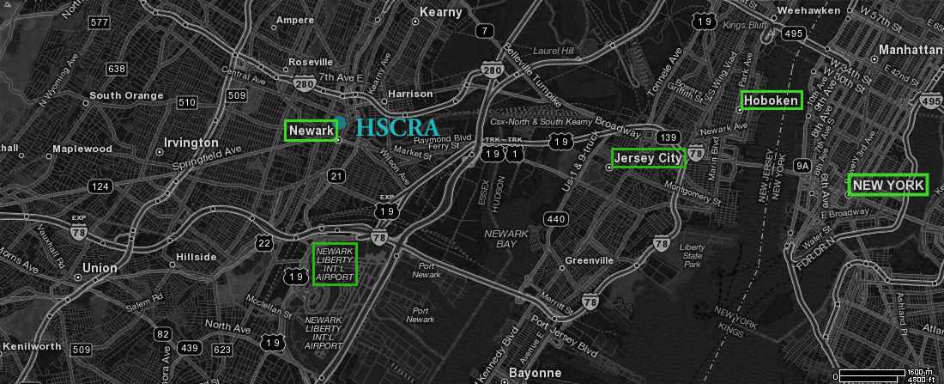
Figure 1: In the Context of the Region

(b) The Area in the Context of the Neighborhood

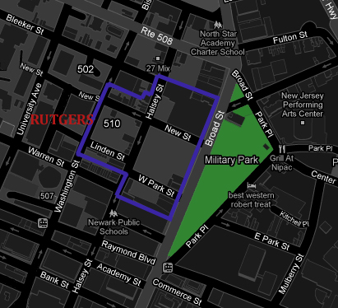

Figure 2: The Halsey Street Commons Redevelopment Area is located in the heart of downtown Newark, amid the blocks of the City’s original, 17th-century street grid. It adjoins Military Park—Newark’s historic green, which dates to 1666—and Rutgers University.
(c) Boundaries of the Redevelopment Area, Showing Blocks & Lots
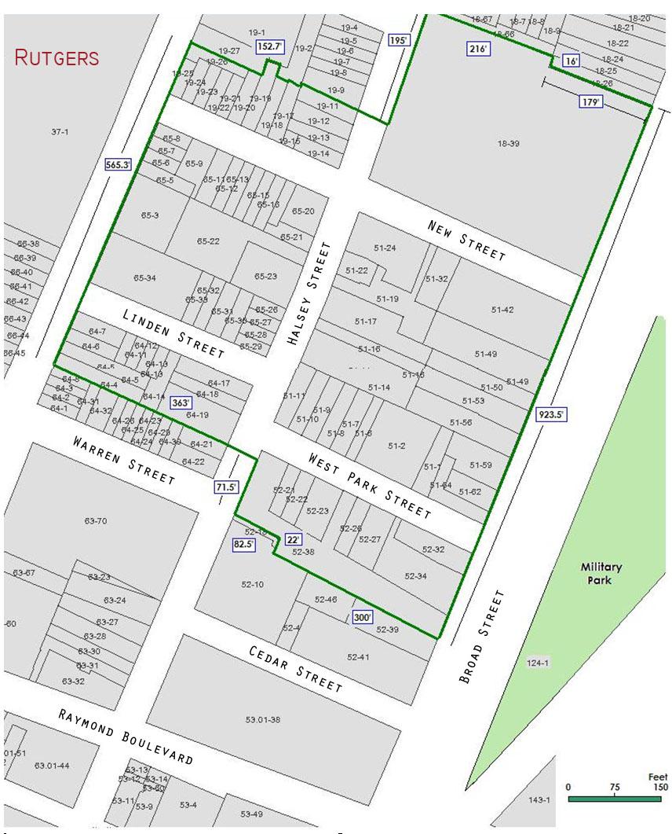
Figure 2: Boundaries, Blocks, and Lots. The Area includes portions of Newark City Blocks 18, 19, 51, 52, 64, and 65. A complete schedule of the Area’s land parcels, showing dimensions, ownership records, assessed values, and last dates of transfer, is included in the Halsey Street Commons Redevelopment Study. Base Map Source: NewGIN

(d) Susceptibility to Change
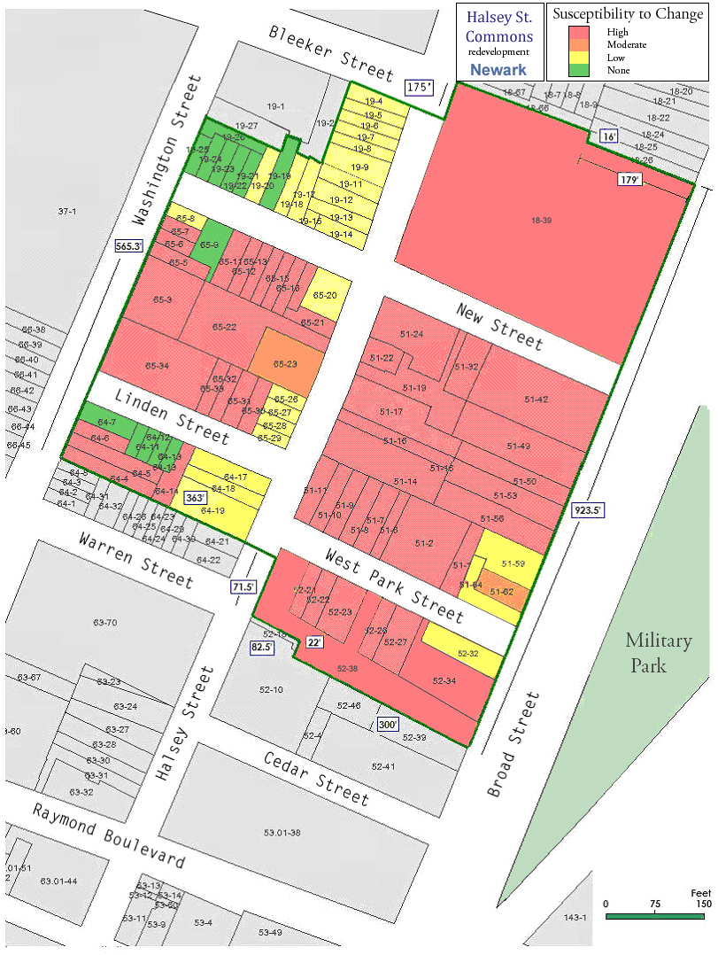
Figure 3: Parcel Susceptibility to Change: Red=High; Orange=Moderate; Yellow=Low; Green=None.

A survey of the Area found that a majority of its land parcels have a high (red) or moderate (orange) susceptibility to change, but some properties in the Area are very well maintained (green), and others are structurally sound, and only in need of cosmetic work (yellow). The retention of the savable stock of mostly older buildings will add both historic character and architectural diversity to the neighborhood, once the Plan is implemented; and their incorporation into the Plan also ensures a significant element of social and structural continuity in the heart of the Area.

(e) Existing Buildings, 2010

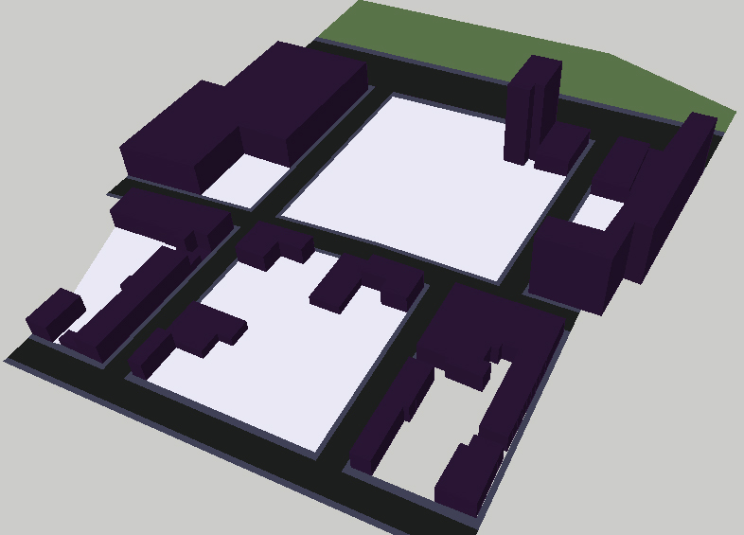

Figure 4: Axonometric view of existing structures, 2010. Military Park is in the background.

(f) Abandoned, Contaminated, and/or Disused Commercial Buildings
Identified pursuant to the Redevelopment and Housing Law, N.J.S.A. 40A:12A-5(b):

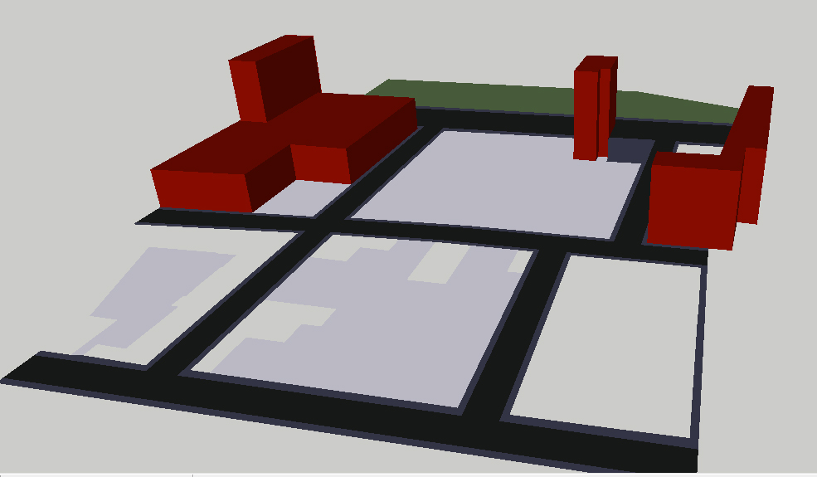
Figure 5: Axonometric view of buildings satisfying Criteria (b) of LRHL.

(g): Paved Parking Fields

Extensive surface parking lots in the heart of the City, interrupting the fabric of their surrounding blocks, constitute a total lack of proper utilization, pursuant to the language of the Local Redevelopment and Housing Law, N.J.S.A. 40A:12A-5(e):

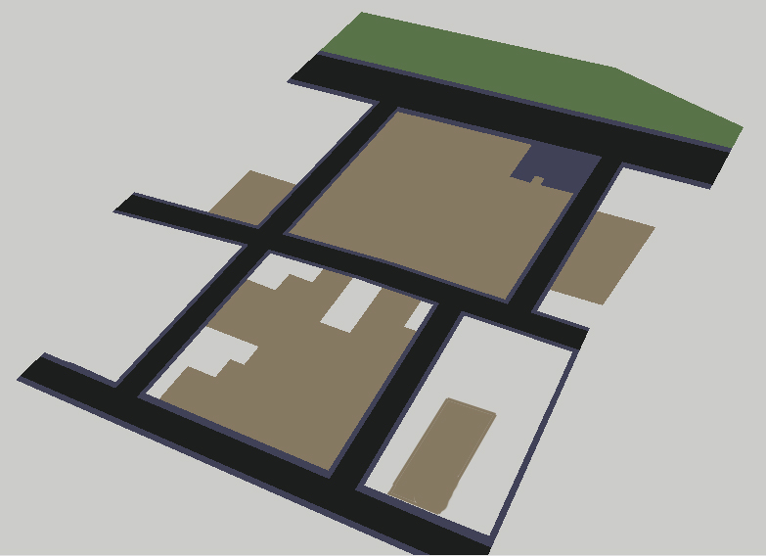
Figure 6: View of parking lots satisfying Criteria (e) of LRHL. Washington Street is in the foreground.

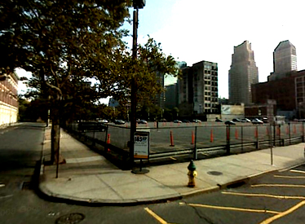

Figure 7: A large, unsightly surface lot occupies the corner of New and Halsey Streets.

(h) Massing Model for Proposed Redevelopment

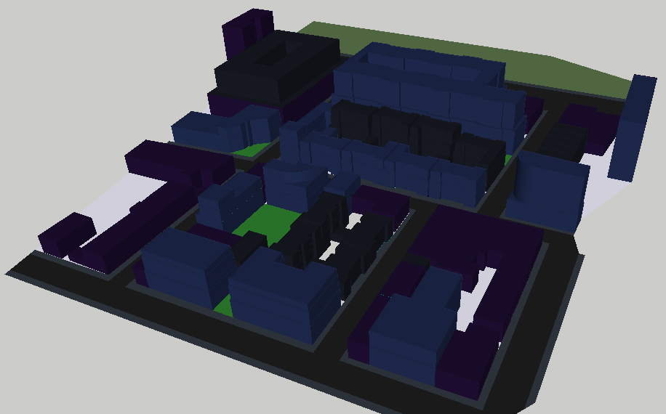
Figure 8: Axonometric model of proposed mass and scale for redevelopment.
(i) Land Use

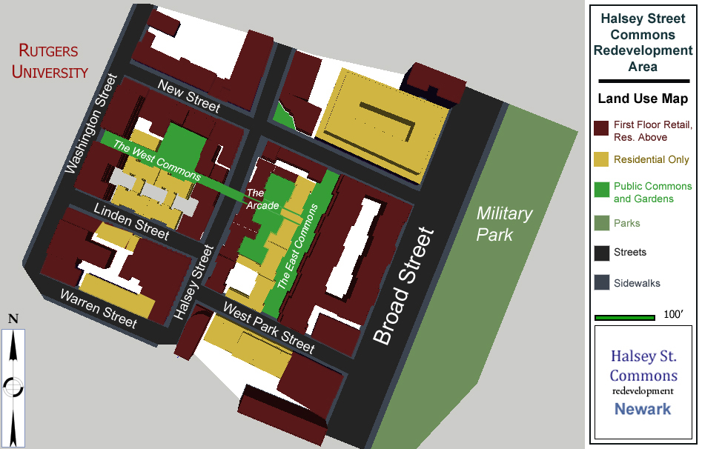
Figure 9: Land Use Map, showing buildings by type, as well as the Pedestrian Commons and Arcade.

III: Land Use Regulating Plan

(a) Application to Existing Uses

Specific application of the land use and development requirements of the Plan to existing uses will be as follows:

1. Existing uses that are nonconforming with the current zoning provisions shall remain nonconforming unless they are expressly permitted in this Plan.

2. Existing principal or accessory uses of properties, permitted by the use provisions of the Land Use Regulations in effect for the Area immediately prior to the effective date of this Plan, but which are not listed as permitted uses in this Plan, shall become prior existing nonconforming uses when this Plan becomes effective.

(b) Permitted Uses

The following uses shall be permitted within the limits of the Halsey Street Commons Redevelopment Area, as depicted in Figure 10 (supra):

1. Mixed Use—First-Floor Retail, with Residential or Office Space Above shall reserve all ground-floor units for street-accessible Retail space, with upper floors reserved for Residential—Multifamily, and Office space. However, Office space shall constitute no more than 40% of the non-Retail Space Floor Area of any single building, and there shall be no upper limit on the proportion of Residential Space—Multifamily which may be allotted in the non-Retail Space of these buildings.

(a) Retail shall permit retail stores, restaurants, and other low-impact, non-wholesale sales and service facilities, including but not limited to grocers, dry cleaners, package stores, florists, pharmacies, booksellers, theaters, cinemas, restaurants, coffee shops, bars, pubs, retail banks, fitness clubs, hardware stores, and clothing stores, as well as retail-type services including, but not limited to, day-care facilities, low-impact repair shops, and small printing facilities. The Land Use Map for Proposed Redevelopment (Figure 10) shows the buildings in which all first-floor, street-facing space shall be reserved for Retail Space.

(b) Residential – Multifamily shall include all premises used exclusively for long-term habitation, and held by residents either through rental or ownership, including, but not limited to, studios, flats, duplexes, triplexes, and penthouses in the forms of rental apartments, co-operative apartments, deeded condominiums, and long-term employer-provided housing. This category expressly excludes all premises whose intended periods of habitation are fewer than sixty days in duration (e.g. rooming houses, boarding houses, S.R.O. buildings, hostels, hotels, inns, etc.). 25 percent of all residential floor space shall be set aside for affordable housing, pursuant to its definition in present interpretations of the Mount Laurel doctrine.

(c) Office shall include all premises used as general, non-industrial workspaces, including, but not limited to, the professional offices of doctors, lawyers, architects, accountants, psychologists, consultants, and urban planners, as well those spaces used for both public and private business administration purposes.

2. Residential – Multifamily shall include all premises used exclusively for long-term habitation, and held by residents either through rental or ownership, including, but not limited to, studios, flats, duplexes, triplexes, and penthouses in the forms of rental apartments, co-operative apartments, deeded condominiums, and long-term employer-provided housing. This category expressly excludes all premises whose intended periods of habitation are fewer than sixty days in duration (e.g. rooming houses, boarding houses, S.R.O. buildings, hostels, hotels, inns, etc.). 25 percent of all residential floor space in each building shall be set aside for affordable housing, pursuant to its definition in present interpretations of the Mount Laurel doctrine.

3. Public Commons and Gardens shall include the exclusively pedestrian realm of the Area, as shown on the Land Use Map, including, but not limited to, the West Commons, the East Commons, and the Arcade. These areas shall be commonly maintained by a newly-created cooperative, funded either by direct annual contributions from the City, or by annual contributions that shall be paid by all property owners in the Area (excluding those individuals and businesses which were already established in the Area prior to the enactment of the Plan), or by any combination of the two. These areas shall be built and maintained according to the specifications of the Landscape Requirements, infra, and shall serve to create a separate realm for pedestrian traffic within in the Area.

4. Parks shall include those facilities of the City’s Division of Parks & Grounds, the Essex County Parks System, a state or national parks service, or any other public parks agency, which are open to the public, are primarily intended for recreation purposes, and are not apparently classifiable in another, more appropriate category for describing their use.

5. Parking shall include embedded, underground, and stand-alone parking structures. The permitted locations for these facilities are shown in Figure P, which is separated from the Land Use Map for purposes of clarity. Limited street parking shall also be permitted throughout the Area, as shown in Figure P. However, under no circumstances shall surface parking lots be permitted to occupy otherwise buildable land in the Area.

6. Civic uses shall include courthouses, police stations, firehouses, and free public libraries, as well as elementary, middle, and high schools. Presently, there are no civic buildings envisioned for the Area, but they shall not be excluded as such. Civic space may be located anywhere within the Area. However, under no circumstances shall civic space be permitted to occupy more than eight (8) percent of the maximum buildable floor area of the entire Area.

7. Religious uses shall include buildings used for regular services by religious institutions, including, but not limited to, churches, synagogues, temples, mosques, and other houses of worship, as well as buildings associated with the customary accessory uses of such buildings, such as meeting halls and rectories, but not including elementary, middle, or high schools, nor any publicly accessible retail space which may be associated with such institutions. Presently, there are no religious uses envisioned for the Area, but religious space is not subject to zoning exclusions, and may be located anywhere within the Area.

(c) Permitted Accessory Uses

A permitted accessory use is a one that shall be permitted because it is customarily both incidental to, and subordinate to, the principal permitted use of the land; and because it is undertaken on the same parcel as the principal permitted, associated use.

(d) Interim Uses

A permitted interim use is a utilization of land for a purpose other than that envisioned by the Plan, but which is permitted during the development phase of the Plan, either to accommodate the development process itself, or to permit the reasonable and equitable use of parcels that have been slated for some future purpose, which has not yet come to fruition. Unless otherwise specified, the periods for which such uses may be permitted shall be determined by the City.

As exceptions to the permanent land use regulations of the Plan, the following interim uses shall be permitted in the Area, during the phasing of redevelopment:

1. Parks and recreation facilities.

2. Surface parking facilities, for no more than six (6) months.

3. Any otherwise lawful and reasonable use that will not encumber the property, or hinder its future development in accordance with the Plan, or interfere with the ongoing redevelopment of the Area in accordance with the Plan.

4. Construction staging areas for the construction of projects pursuant to the Plan, or for the construction of projects on adjacent land, outside the scope of the Plan, but pursuant to all other requirements of the City’s Zoning Law.

5. Aggregate plants, including concrete and asphalt plants, used exclusively for the construction of projects pursuant to the Plan.

6. Temporary signage, advertising the developments and their sponsors.

(e) Prohibited Uses

Any use not permitted by the Plan shall be prohibited within the Area. The following are examples of some, but not all, prohibited uses:

1. Drive-through retail, including, but not limited to, drive-through banks, pharmacies, and fast-food assembly facilities.

2. Gasoline stations, service stations, and car wash facilities.

3. Outdoor vending machines.

4. Billboards, “ticker” signs, outdoor video screens, outdoor speakers, or any form of advertising that is not in compliance with the requirements of the Signs section.

5. Kennels, pounds, feed lots, factory farms, stockyards, abattoirs, slaughterhouses, wholesale fish markets, commercial aquariums, and animal husbandry facilities.

6. Warehouses for large scale storage or distribution of goods.

7. Scrap yards or junkyards for the processing, storage, and disposal of waste materials.

8. Cemeteries, crematoria, mausoleums, and morgues.

9. Stores selling firearms, ammunition, and/or dangerous explosives.

10. Adverse Impacts, in General: Includes uses with negative consequences for a permitted use on an adjacent lot or lots, including but not limited to offensive odor, vibration, noise, smoke, light, or pollution. Consequences confined to the lot boundary are not considered to create such an impact.

11. Surface parking lots, except for temporary parking lots during periods of construction or demolition.

12. Chain link fencing (except during construction), razor wire, barbed wire, vicious dogs, or similar unsightly and/or violent deterrents to trespass.

13. Manufacturing facilities, except for small craft shops or artisan workspaces.

14. Any building, utility line or other improvements which would cause a violation of any of the terms and conditions of the Deed Notice, is prohibited.
IV: Mobility Plan
(a) Thoroughfares

The thoroughfare regulations describe the lanes for vehicles, bicycles, and pedestrians. Sidewalks and landscaping along these thoroughfares are required, as prescribed by the Plan. The following standards must apply:

1. The rights-of-way in the Area are among the oldest blocks in the United States. In attempting to reweave the fabric of this historic Area, it is important to be cautious about revising its established street pattern. In accordance with the historical qualities of the neighborhood, the Plan is pedestrian-focused. It considers that the neighborhood was originally built for non-motorized modes of mobility, and that its scale and design remain most compatible with ways of movement that do not require an automobile.

2. The Plan calls for a Radburn-style separation of the vehicular and pedestrian realms. All vehicular thoroughfares will have well-designed and well-buffered sidewalks, and there will also be an entirely separate realm of pedestrian thoroughfares—namely the Commons and the Arcade—which crisscross the Area by their own distinct routes.

3. Vehicular streets shall include traffic-calming measures in order to discourage speeding, give priority to pedestrians and bicyclists, and ensure the absolute highest degrees of safety and comfort for all persons on the street.

4. Since not everyone with reason to visit the Area will be able to reach the Area by foot, bicycle, or public transportation, and since residents may wish to keep motor vehicles of their own, the Plan seeks to address the needs of motorists as thoroughly as possible, but to do so without allowing those needs to override the safety, comfort, or other considerations of the Area’s pedestrians and bicyclists.

5. Each thoroughfare shall have a detailed schedule of specifications (Thoroughfare Specifications, infra), which shall provide for its specific dimensions, including its right-of-way width, pavement width, sidewalk width, traffic lanes, parking lanes, etc. Meanwhile, street trees, planting treatments, pavement types, and styles of lamp posts, sign posts, signal arms, parking meters, benches, bus shelters, and other elements of both functional and aesthetic design characteristics specific to the particular thoroughfare, shall be addressed in the Landscape Plan. Specifications contained in the Thoroughfare Schedules and Landscape Plan shall be binding upon the Redevelopment Entity, and/or its Redeveloper assignees.

6. The West Commons and East Commons shall comprise the major thoroughfares of the pedestrian realm. The former shall connect the sidewalks of Washington Street with those of Halsey Street, and the latter shall connect the sidewalks of New Street with those of West Park Street. A pair of open-air arcades, passing through the ground-floor level of the buildings on the eastern block face of Halsey Street, shall connect the two commons, and by doing so, they shall form a continuous pedestrian realm, having its own distinct routes.

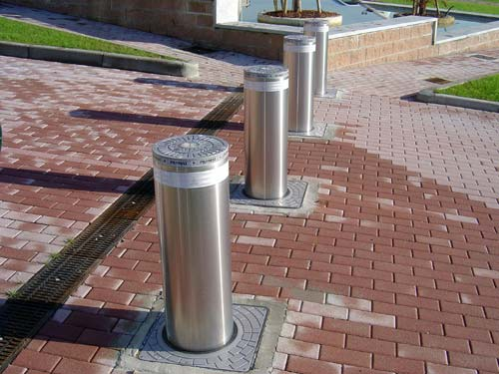
7. The West Commons and East Commons are proposed to serve both as retail corridors and as points of access to lobbies serving the upper-floor residential and office spaces in adjoining buildings. Some, though not all, of the ground-floor adjoining space shall be reserved for retail use. In accordance with this Plan, retractable bollards shall be placed at certain entry points to the Commons, from regularly trafficked streets, in order to permit delivery vehicles to access these spaces at select times; and to permit access for emergency vehicles, if necessary. Under no circumstances shall the operation of motor vehicles be otherwise permitted within the pedestrian realm.

Figure 10: Retractable Bollards
8. The Commons and Arcade shall have a continuous, distinctive pavement that extends across Halsey Street. See the Landscape Requirements for specifications.

9. Bicycle lanes shall have a continuous, distinctive pavement that extends through all intersections. See the Landscape Requirements for specifications.

10. Curbside parking shall be provided for in accordance with the specifications of Figure P. All curbside parking spaces shall be metered and limited to maximum parking periods of four (4) consecutive hours, between 8 a.m. and 8 p.m. Evenings, nights, weekends, and holidays, shall have curbside parking spaces available free of charge. Curbside parking spaces shall be equally available to all motorists, and shall not be reserved for any particular class, use, or tenant, except for the requisite number of spaces reserved for handicapped persons.

(b) Transit

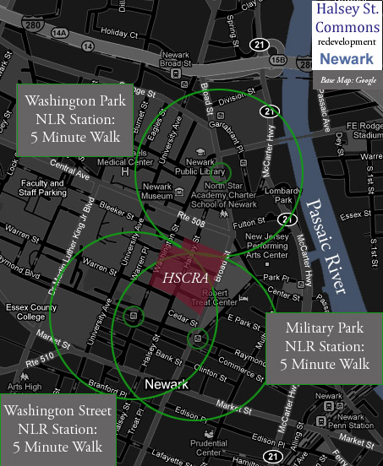
1. The Newark Light Rail has subway stations at Military Park, and at Washington Street, both of which are within a five-minute walk of the Area; it also has an inbound surface station at Washington Park, which is within a five-minute walk of the Area, as well. The Area is directly linked to NJ Transit’s heavy rail, PATH, Amtrak, and numerous bus lines through its NLR connections. The Plan is made in consideration of the Area’s proximity of these facilities, which are anticipated to reduce the necessity of motor vehicle trips to and from the Area.

2. The Plan endorses the exploration of the potential to repurpose the disused Cedar Street subway, which emerges from a tunnel entrance just south of Warren Street. The Plan’s design specifications for Washington Street are made to facilitate its possible future conversion to restore old streetcar rights-of-way for future LRT use.

3. Bus stops serving the NJ Transit bus lines on Broad Street shall be outfitted with new, high-quality shelters that are attractive, lighted, monitored by security camera, and protected from the elements. See the Landscape Plan for design specifications.

(c) Pedestrian Realm

1. The Pedestrian Realm shall include the West Commons, the East Commons, and the Arcade, as well as all of the sidewalks, planting strips, and semi-public edges that run parallel to the Area’s vehicular thoroughfares.

2. Dimensions of the pedestrian realm are specified in the Thoroughfare Specifications, which prioritize the highest degree of safety and comfort for pedestrians in the Area, and also seek to consider the needs of the Area’s motorists.

3. Design characteristics, including paving types, street trees, planting treatments, lamp posts, sign posts, signal arms, parking meters, benches, bus shelters, and other functional and aesthetic elements, shall be addressed in the Landscape Plan.

4. For the safety of pedestrians and bicyclists, right turns on red lights shall not be permitted.

5. Pedestrian signals shall be installed as necessary by the City or the Essex County Highway Department, pursuant to generally accepted traffic engineering standards. Traffic signage shall be consolidated and affixed onto lampposts and traffic signal posts, wherever practical, to reduce the number of poles, obstructions and visual clutter in the streetscape and to facilitate pedestrian movement.
(e) Thoroughfare Specifications

(1) Linden Street:
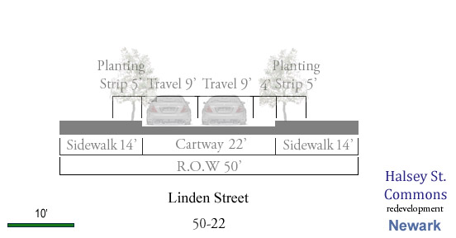
Figure 11: Cross Section of Linden Street

(2) New Street:
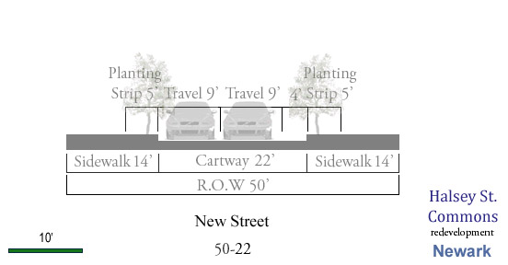
Figure 12: Cross Section of New Street.
(3) West Park Street:

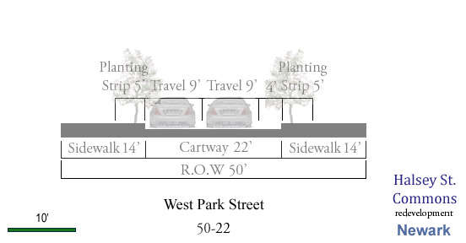
Figure 13: Cross Section of West Park Street.

(4) Halsey Street
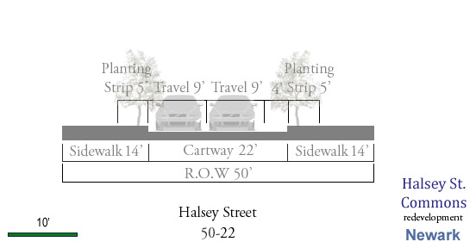
Figure 14: Cross Section of Halsey Street.

(5) Broad Street
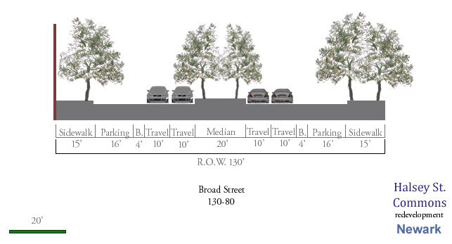
Figure 15: Cross Section of Broad Street.

(6) Washington Street
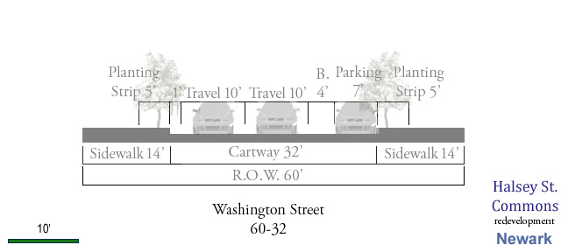
Figure 16: Cross Section of Washington Street.
(f) Loading and Disposal Regulations

To maintain high aesthetic and functional standards, it is necessary to establish certain restrictions on the locations of loading areas and garbage/recycling disposal facilities within the Area. Absent appropriate regulation, such facilities carry a broad potential for interference with the flows of pedestrian and vehicular traffic, and carry a broad potential to create unwanted noises, odors, and visual distractions that may constitute public nuisances. Therefore, to protect the health, safety, and welfare of all persons in the Area, the Plan adopts the following regulations:

1. Loading and disposal facilities in the Area shall be permitted only in accordance with the specifications and conditions of the Loading and Disposal Map (Figure L). In all structures whose construction shall commence subsequent to the adoption of this Plan, loading areas shall be situated within the interior of the structure, and accessible via a 24-foot-wide, two-story-high access ramp, which leads directly into the service and/or staging area.

2. Prior to project approval, developers proposing projects within the Area shall be required to demonstrate that sufficient off-street loading and disposal capacity has been provided for in their plans to effectively meet the needs of their proposed use(s). In all structures whose construction shall commence subsequent to the adoption of this Plan, there shall be a requisite minimum of one loading and disposal area per building.

3. All loading and disposal operations in the Area shall be conducted with efforts to avoid disrupting vehicular and pedestrian movement. Pursuant to this objective, off-street loading areas shall be provided with mechanical gates and/or doors, complementing the architecture of their respective structures, which minimize the aesthetic and audible externalities of the loading and disposal activities performed within.

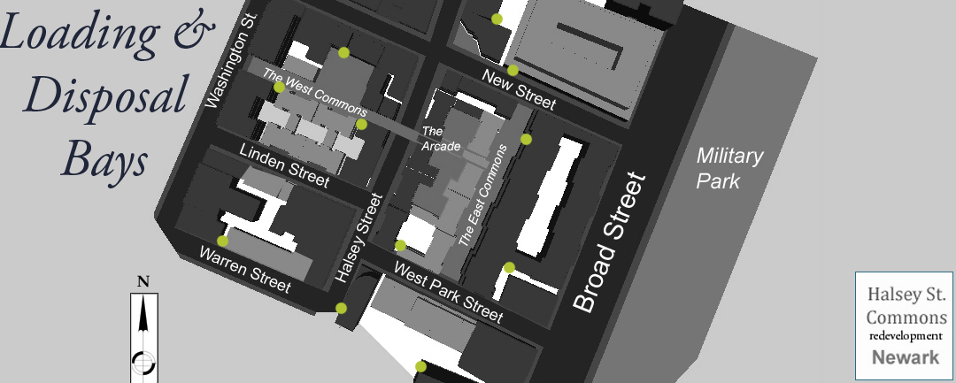
V: Building Regulating Plan

A mix of uses makes for a vibrant, dynamic neighborhood. Single-family homes, apartments of various sizes, retail stores, and professional offices can all share the same block—or even the same building. But just as the variety of uses must be complementary in order to enrich the experience and atmosphere of a compact place, design standards must also be expressed in a harmonious vocabulary.

(a.) Building Heights

Among the most important factors which contribute to the aesthetic cohesion of a meaningful place are the sizes and shapes of its structures. In neighborhood architecture, variety is good—it creates texture, distinguishes buildings, and defines individual spaces. But the tendency toward variety must be balanced by a guiding sense of order. Since the Plan calls for retaining a significant number of the Area’s existing buildings, it is important that any new development builds on the physical scale that is established by the existing fabric of the neighborhood.

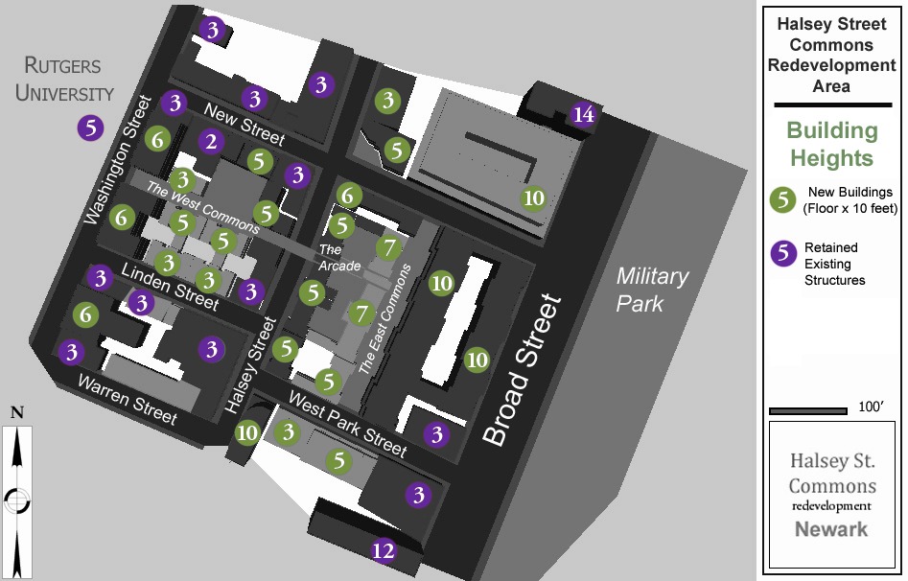
Figure 17: Building Height Regulating Plan.

In accordance with this goal, the Plan provides the following requirements for building heights. These standards are intended to complement the Area’s retained existing structures, to create a rich texture in the building stock of the Area’s newly developing spaces, and to permit a significant increase in both the density and variety of uses in the Area. The map below corresponds to the Land Use Map, supra, and sets forth a pattern of varied but complementary building heights for new development in the Area. Meanwhile, the heights of retained existing buildings are noted herein, in order to illustrate their physical relationship to the standards that are hereby enacted under the Plan.

(b.) Structural Massing

(1) In keeping with the traditional architectural approaches of European and American cities, building devices such as courtyards, commons, and paved yards shall be employed liberally, in addition to the rights-of-way of vehicular thoroughfares, to ensure the highest possible ratio of buildable floor space to buildable land, consistent with the appropriate scale of development. The employment of these devices shall be substantially consistent with their designed employment in the Plan’s Land Use Map; however, minor variations to the design may be permitted to facilitate the best use of a particular parcel.

(2) In employing the devices described in (b)(1), all existing building code requirements regarding light, air, and means of egress shall be observed. The use of airshafts, bounding alleys, open-air stairwells, or other inferior devices to technically satisfy light, air, and egress requirements shall be strictly prohibited.

(3) New construction shall not unreasonably compromise access to light, air, or means of egress of existing structures. The reasonableness of such compromises shall be determined by standards for the new target density of the Block, and not by existing conditions, whether at the time of enactment, or at some later time.

(4) Building façades shall be constructed to the build-to lines of their respective lots. The maps below illustrate the statutory locations of build-to lines in the Area. The specifications provided in the map shall replace any existing specifications for the Area that may be provided in the Municipal Zoning Law:

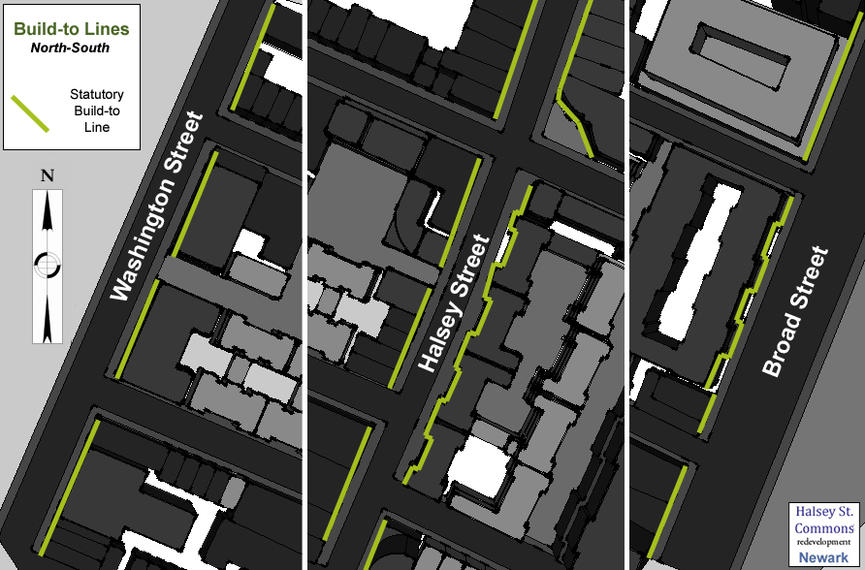
Figure 18: Statutory Build-to Lines for North-South thoroughfares.

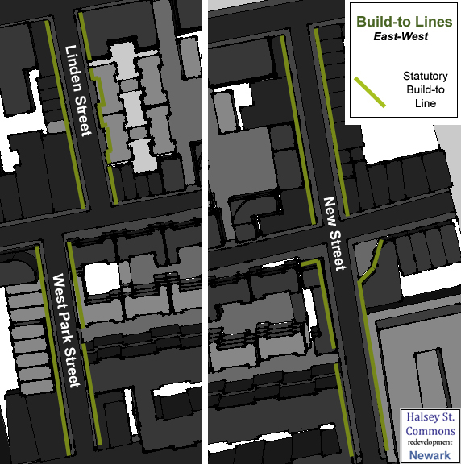
Figure 19: Statutory build-to lines for East-West thoroughfares.
Finally, an axonometric view demonstrates the three-dimensional qualities of the vision:

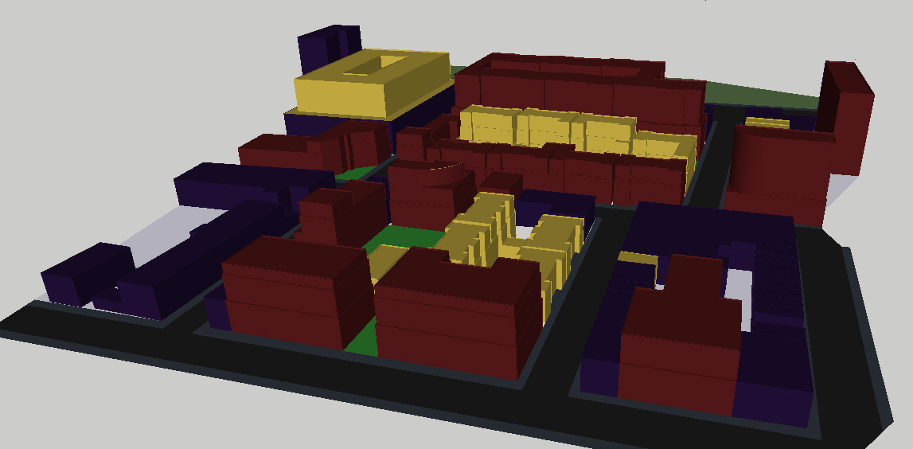
Figure 20: Plan’s vision of massing of the Area: Red=New Mixed Use, Yellow=New Residential, Violet=Retained Existing.
(c.) Architectural Regulations

In addition to the macro-considerations of building sizes and shapes, it is necessary to consider the aesthetic impact of the Area’s architectural approach. As with structural massing, the effect of smaller-scale design elements is most satisfactory when it strikes a balance between rich complexity and a guiding order. The architectural regulations of the Plan seek to attain that balance.

- General Architectural Regulations. To ensure the visual, spatial, and general aesthetic quality of the Area, all building footprints and façade designs shall conform to the standards outlined in this plan.

- Design Professional Review. In addition to complying with the standards of the Plan, all proposed façades shall be submitted for review to a team of design professionals, selected and retained by the Planning Board in accordance with the Development Review Process set forth in Section 8, below. Each project shall be reviewed individually in sketch and preliminary form, including plans, elevations, and actual or virtual models. Members of the design review team shall submit their comments and recommendations to the Planning Board regarding each façade proposal, wherein they shall a variety of factors, including but not limited to proposals for façade arrangements, finishing materials, color palettes, and landscaping. The design review team’s recommendations shall be given appropriate weight by the Planning Board when contemplating the approval or rejection of any project.

- Façade Style. For buildings greater than three stories, and buildings with street facings that exceed 25 feet, each façade shall be expressed in a tripartite discussion which emphasizes a base, a middle, and a top.

- Façade Materials: Façades shall primarily consist of masonry and/or stone at the articulated base of all buildings with the exception of towers which may incorporate more metal or glass surfaces. To avoid discordance, façades shall consist of no more than three primary materials, textures, or colors, excluding windows and framing. All transitions in the primary façade material of a single building must occur horizontally, with traditionally heavier materials situated below lighter ones. For example:

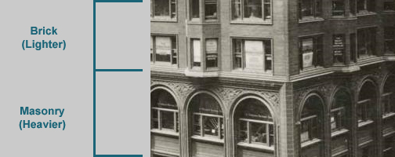
Figure 21: Traditional façade materials transition. Note that the change occurs along a horizontal line.

- Façade Colors. The colors of primary façade brick, woodwork, stucco, and other materials above the articulated base, if any, shall be selected from the range of a prescribed palette. The range of colors included in this palette shall be binding, but shall not be mandatory for windows, window frames, doors, door frames, entranceways, fixtures, signs, details, or trim, nor shall it apply to the selection of exterior materials for any building façades above the height of fifty feet, in places where such heights are permitted. The palette includes a range of from red-brown to light tan:


Figure 22: Brick, woodwork, and stucco façade palette.

- Identifiable Building Widths (IBW) establish the individuality of attached buildings, while maintaining a continuous block face at the build-to line. IBW are accomplished by material and/or textural transitions at the vertical line where adjacent buildings are joined. Each adjoining building in the Area shall be distinguished from the next by its IBW, through changes in material, colors, window and door treatments, projected window bays, stoops, porches or portico treatments, masonry pattern design, cornice treatments, pilaster or style characteristics.

- Corner Emphases and Landmark Architectural Elements. Corners which are major architectural landmarks must have additional height or embellishments which extend at least 20 feet on both sides from the corner. Such expressions must include, but shall not be limited to, projections, towers, roof forms, height increases, or other architectural appurtenances appropriate to the scale and architectural expression and style selected. Major landmarks must be more prominent than minor landmarks.

- Stepbacks. Stepbacks of taller buildings can maintain the cornice-line of the block face, provide architectural integrity, and allow a greater amount of sunlight to reach the floors closest to the street. For buildings taller than 30 feet, a minimum five-foot stepback is required at the height of 30 feet. For buildings taller than 50 feet, a minimum two-foot stepback is required at the height of 50 feet.

- Façade Articulation. In order to create unique block faces within the Area, two façades on any block shall not be identical.

- Façade Ratio. The percentage of void area, including windows, terrace doors, and other apertures, shall comprise between 40% and 60% of the façade, except at street-level retail frontages, where it shall comprise at least 75% of the façade.

- Façade Composition. Each façade shall present a unified, rational composition. Scattered-window façades shall not be allowed at frontages. Mechanical equipment, vents, grills, and other HVAC equipment shall not be exposed on the primary façade.

- Expansion Joints. Façades shall be designed so that any expansion joints are rationalized by the logic of the composition, and thus made less obvious. Expansion joint gaps shall be colored to match the surrounding wall.

- Blank Walls. Walls at frontages shall not be blank and shall have at least one window per structural bay, in a pattern that suggests habitation. Exposed basement walls at frontages shall have at least one small window per structural bay as appropriate to an occupied foundation.

- Exterior Insulation Finishing Systems (EIFS) are prohibited.

- Horizontal Articulation. Concrete slabs must be hidden.

- Cornices and Cornice Line Variations. Cornices and cornice line variations are required. An intermediate cornice on buildings is required for structures over five stories.

- Windows. All windows in residential units shall be operable, to ensure natural ventilation and air circulation.

- Header and Sill Emphasis. Window headers and window sills shall be emphasized. Exterior window frames shall be of complementary or contrasting colors to the primary façade material against which they are seen. For residential units, ground floor window sills shall be a minimum of five feet above the sidewalk.

- Window Glass. Glass curtain walls shall be permitted for offices and towers only. Mirrored glass shall not be permitted.

- Strip Windows. Strip windows shall not be permitted in the Area. No windows may have a width-height ratio greater than 5:2, except for ground floor retail, transom, and clerestory/skylight windows.

- Balconies. Balconies along the first to fourth stories shall extend no further than 24 inches beyond the build-to-line. Balconies must have semi-opaque railings.

- Roofs. The typical roof shall be flat, with a minimum pitch for drainage, and with an accented cornice and/or decorative parapet. Roofs having a gentle slope shall have their pitches minimized to an angle of 10% or less, and shall only be permitted on buildings with a height of thirty feet or less, or as occasional accents on taller buildings. Rooftop mechanical equipment, including satellite dishes, television antennas, and radio antennas shall either be incorporated into the volume of the building, or be screened from view in order to minimize their negative aesthetic impact from street level and from surrounding buildings. Any screening shall be consistent with the architectural design and materials intended for the building, generally.

- Rooftop Decks. The railings or safety barriers that surround the edges of rooftop decks shall be made of wrought iron, brushed aluminum, and/or tinted glass. Permanent fixtures on rooftop decks, including but not limited to planters, greenhouses, parasol tables, swimming pool appurtenances, and head-houses enclosing elevator and stairwell entrances shall be set back sufficiently as to not be visible from the street. Parapets shall not be permitted as a means of obscuring the presence of rooftop activity.

- Rain Gutters are prohibited.

- Green Roofs and Terraces shall be required over interior-block parking structures, unless such structures are topped by units. Green roofs and terraces shall be comprised of an engineered roofing system that enables the growth of vegetation.

- Building Entrances. Every building shall have a primary pedestrian entrance that opens onto the sidewalk or the pedestrian commons. In buildings with two or more uses, each use shall have a separate entrance; in buildings with two or more units of the same type, each entrance shall include a vestibule and lobby. Furthermore, every apartment and office unit within a building shall be provided with a path to and from such entrance, which shall not pass through a parking garage. Each entrance shall be clearly marked with street number and the name of the building, and no two lobby entrances on a single block shall be identical. Every retail and commercial establishment shall have a separate, primary entrance at the sidewalk or the pedestrian commons.

- Exterior Stairs and handrails. Stairs extending from a patio to the sidewalk shall be of high quality construction. Stairway details shall vary from building to building. Risers shall be built of stone, masonry, or a high-quality prefabricated decorative metal. Hand rails shall be decorative and architecturally integrated with the design of the building. If stairway is parallel to building façade, stairway and rails shall be at least 75% transparent.

- Eaves. All building eaves and overhangs shall be designed to provide shade in the summer and allow sunlight to enter the building in the winter. As such, southern and western exposures shall feature exaggerated eaves.

- Awnings shall be 5 feet to 10 feet deep and shall not place supports upon the public sidewalk or the pedestrian commons. Further, canvas awnings shall be retractable and rectangular with no side panels.

- Arcades must be a minimum of 24 feet high and a minimum of 15 feet deep to keep them full of light but sufficient to provide shelter from rain, sun, and snow.

- Parking Façades: Parking structures shall not directly front the sidewalk. Where under building parking exists, the façade of the building must mimic a basement façade with real windows and must be fully ventilated.

- Parking Entrances and Exits: Parking entrances and exits shall be a minimum of 18 feet wide, and shall be fitted with a closable door which complements the building’s design and color palette. Mid-block parking entrances shall not be entered through gaps between buildings, but shall be incorporated into the blockface wall of a building. Mid-block parking entrances shall provide direct pedestrian access to sidewalks so that residents may exit the parking lot without entering a building. Such vertical circulation, if located within the liner building, shall be fenestrated to approximate a residential stairwell, and shall be lit in the daylight-incandescent range.

- Entry Lighting: Lighting of every entryway is required. Lighting fixtures shall be of a finish, style, and character appropriate to the architecture and details of the building.

- Service and loading dock doors shall be closed when not in use, and shall be visually integrated into the design of the façade.

- General Signage Requirements. All signage shall be designed to complement the architectural design and character of the buildings, streets and the use that it serves. Signage shall be pedestrian-oriented around the East Commons, the West Commons, throughout the Arcade, and in other places where it is primarily directed to pedestrians.

- Comprehensive Public Signage Plan: In order to regulate signage within the Area, the designated Redeveloper(s) shall submit a Comprehensive Signage Plan to the Planning Board. The signage package shall address the design and size limitations for all signage within the Redevelopment Area. This shall include: way-finding and directional signage; identification signage for the overall project; and street signs.

- Roof-top Mounted Signs are prohibited.

- Signage on Lobby Residential Uses. No sign exceed 20 square feet. Mailboxes, buzzers, and intercoms shall be flush-mounted to a wall or partition within the vestibule between the street and lobby doors, rather than on the masonry façade of the building.

- Building Numbers: Unless incorporated into the artful design of etched or stained glass entranceways (including transom windows), or the artful design of tiled mosaics at such entranceways, building and unit numbers shall be expressed in digits no greater than six inches in height. Under no circumstances shall such numbers be expressed through the use of multicolored lighting effects or reflective decals.

- Ground Floor Commercial Signage. Each retail use shall have exterior signage not to exceed five percent of the area or the storefront (ground floor) to which it is attached. Window signage shall not exceed 25 percent of the glazed area. If included, blade signs and hanging arcade signs must not be more than 15 square feet. If a sign is flush mounted, it must not exceed 40 square feet.

- Office Use Signage. Each building shall have a sign indicating the name of the office building or major tenant. Such sign shall be flush mounted to the façade of the building. In addition, each office building may have a directory sign flush mounted to the building. Flush mounted building identification signage shall be no larger than the average story height and twenty percent of the width of the building.

- Construction Signage. Construction signs shall not exceed an area of 300 square feet, and shall be removed upon completion of the project or development.

- Prohibited Signage. Fluorescent-lit signage, signage with glowing paint, rooftop-mounted advertising, signage above the second floor, and signs that might be mistaken for traffic control devices, shall be prohibited.

- Freestanding Signage. Signs freestanding from actual buildings are prohibited, with the exception of way-finding, directional, and street signage, as installed by or with the approval of the appropriate City officials.

- Signage Illumination. No backlit plastic or underside canopy signage shall be allowed.

(c.) Suggested Architectural Regulations

- Architects. All buildings and façades should be designed by registered architects who have experience in this scale and character of urban design.

- Sustainable Design. All new buildings and gut renovations in the Area should conform to the standards of US Green Building Council’s LEED green building rating program. At a minimum, all building interiors should be designed with environmental considerations in mind. This includes designs to maximize the energy performance of the wall, natural day-lighting, passive solar orientation considerations, passive fenestration, and natural ventilation.

- Materials. A palette of materials including masonry, brick, metal, and glass is suggested in an attached schedule.

- Style. Three recommended styles for the 4 to 6 story height range only are contemporary, “green building”, and Victorian. Each style should be expressed in a tripartite discussion of the façade which emphasizes a base, middle, and top.

- Façade Glass. Where glass is used, clear, tinted green or blue is recommended.

- Corner Emphasis and Key Architectural Elements. Major landmarks should typically be located on the primary corners at the intersection of primary streets and terminating vistas. Minor landmarks should be incorporated on secondary corners along major streets. Minor landmarks on corners can be accomplished by the use of the chamfered corners and slight changes in height.

- Vertical Articulation. The vertical articulation of the façade can best be expressed by the IBW and can be supplemented by the change of the floor heights, height of parapets, design of the corners and form of the windows.

- Horizontal Articulation. In addition to cornice lines and stepbacks, a building may employ horizontal articulation through banding in masonry and metal and/or a change in materials of the primary façade. Where a stepback is required, a two (2) to six (6) foot banding of masonry or metal is suggested at the top of the story prior to the stepback. If a building is less than six (6) stories, a banding (between two (2) and six (6) feet) of metal or masonry is suggested between the first and second stories.

- Cornices and Cornice Line Variations. Each IBW should have a unique cornice design. The cornices along a block should emphasize the distinctness of attached buildings.

- Windows. Clerestories, transom windows, sidelights, and skylights are encouraged as means of distributing a greater measure of sunlight to the interior spaces of units, and such windows should be functionally operable, except where safety or security considerations would make their non-operability preferable.

- Mullions should be used in residential windows which face onto sidewalks and courtyards. However, they should be avoided on retail shop windows, when such windows require transparency for display purposes.

- Balconies. In the floors above a stepback, a balcony may not extend further than the width of the next lowest stepback line.

- Parapets. Parapets should include sufficient changes in height, slope, and decoration to accent building widths, visual terminations, and stepbacks.

- Building Entrances. Where units share a common entrance from the street to a lobby, such entry should be of unique design, expressed through design of its doors, latticework, sidelights, and transom windows; with features such as etched glass, tiled mosaics, murals, distinctive light fixtures, memorable color palettes; and through the artful design of functional devices such as handrails, steps, flooring, mailbox alcoves, concierge desks, porticos, and/or awnings.

- Soffits. Design of the soffits or eaves should receive careful attention.

- Parking Façades. All exposed façades should be designed to eliminate headlight lamp glare by use of opaque spandrel at least 42 inches above the floor line in all openings.

- Parking Frontage. All exposed façades should be designed to eliminate headlight lamp glare by use of opaque spandrel at least 42 inches above the floor line in all openings.

- Outdoor Retail. Outdoor retail may extend up to two stories with high arcades, large display windows, outdoor displays, and engaging signage.

- Outdoor Dining. Outdoor cafes and restaurants are strongly encouraged along the East Commons, West Commons, and throughout the Area where the zoning provides for ground floor retail establishments.

- Special Use Signs. Certain uses such as commercial recreation and entertainment uses, theaters, hotels, and similar uses have unique signage requirements. For these uses, marquees, animated signage and signage that is painted on or integrated into a building façade or is otherwise integral with the architecture of the building may be permitted.

- Signage on Lobby Residential Uses. Each residential building may provide necessary signage required for proper mail delivery indicating the name(s) of the resident(s) on the building on the mailbox or doorbell.

- Residential Building or Unit Numbers. Numbers may be located on the transom above a primary entrance, incorporated into transom windows or sidelights, affixed to street doors, otherwise artfully incorporated into the design of an entrance, or into the adjacent street level of the building’s façade.

- Ground Floor Commercial Signage. A flush mounted sign and a blade sign may be used, provided that the total signage does not exceed the maximum permitted amount.

- Signage Illumination. To the extent possible, lighting levels for signage must be controllable, limited and significantly reduced at times of low pedestrian or vehicular activity.

- Green Roofs. Green roofs on the top of each building are strongly recommended to improve air quality and reduce storm-water runoff and heat island effect.

- Bicycle Storage. Commercial and institutional buildings should provide shower and changing facilities in the building (or within 200 yards of a building entrance). Residential buildings should provide covered storage facilities for securing bicycles for 15% or more of building occupants.

- Wastewater. Consideration should be given to reducing potable water use for building sewage conveyance by 50% through the use of water-conserving fixtures or non-potable water, recycled grey water, and on-site or municipally-treated wastewater.

- Water Reduction. Consideration should be given to using 20% less water than the water use baseline calculated for the building (not including irrigation) after meeting the Energy Policy Act of 1992 fixture performance requirements. Consideration should also be given to reuse of storm water and grey water for non-potable applications such as flushing and custodial uses.

- Heat Island Effect. To diminish the potential for the Area’s high-density development to create a heat island effect, developers should be provided with incentives for installing planted green roofs on at least 50% of the Area’s buildings, and also for installing roofing materials which reflect, rather than trap, solar heat.

- Energy Performance. Consideration should be given to maximizing energy efficiency when designing the building envelopes, HVAC, lighting, and other systems in new buildings and gut renovations.

- On-Site Renewable Energy. New projects should be assessed for their non-polluting, renewable energy source potentials, including their ability to house infrastructure for new solar, wind, and hydroelectric energy production. In consideration of these potentials, the Redeveloper(s) shall coordinate its work with the appropriate public utilities.

- Storage and Collection of Recyclables. The size and functionality of trash and recycling facilities should be coordinated with the anticipated collection services to maximize the effectiveness of the dedicated areas. Functionality considerations should include the potential use of cardboard balers, aluminum can crushers, recycling chutes, and trash collection bins at individual areas.

- Regionally Organic Materials. Whenever possible, the Redeveloper(s) should seek to use stones, bricks, and timber products that have been extracted or cut from natural sources in New Jersey, New York, Pennsylvania, or Connecticut, or materials from other sources which also naturally occur in neighboring states.

- Rapidly Renewable Materials. Wherever possible, the Redeveloper(s) should seek to use rapidly renewable materials, defined as those which are sourced from plants that are typically harvested within a ten-year cycle. Examples of such materials include bamboo, wool, cotton, agrifiber, linoleum, strawboard, and cork.

VI: Landscape Plan

The Landscape Plan establishes a set of standards to address the design considerations of the Area’s pedestrian realm, including the East Commons, the West Commons, the sidewalks, the open spaces, and the visual elements appurtenant to each of these realms. In addition to their layouts, dimensions, and functions, the Plan provides standards for permanent fixtures that will be placed in each of these settings. Such fixtures include paving stones, lamp posts, street furniture, and recommended plants. Broadly, the Landscape Plan seeks to establish a seamless pedestrian realm between the Area’s sidewalks, commons, and open spaces, with landscaping standards that complement the other goals of the Plan.

(a) Individual Site Plans for Private Parcels

All site plans for individual sites shall be subject to review and approval by the Planning Board. Also, the Planning Board may forward any site plan to the City Engineer for review and comment. In addition to the standard criteria, all site plans shall be reviewed for their compliance with the following requirements and guidelines:

(1.) Site Plans. A detailed site plan, drafted in accordance with the specifications of the Landscape Plan, shall be prepared by a certified landscape architect, for each proposal. Each site plan shall provide a description of its proposed site development, including its share of space in the semi-public edge. At minimum, each site plan shall provide for the use of high quality materials, and shall specify the types and colors of paving stones, curbs, and other hardscape materials; the types and qualities of decorative lighting fixtures; the specific colors and materials to be used in decorative furnishings; and the locations and quantities of each selection. Also, each site plan shall include descriptions of the species, sizes, and plantings for all proposed vegetation, of which native plants should be preferred to all other alternatives. Every element of each individual site plan should complement the elements of the Landscape Plan which are provided for any adjacent public area.

(2.) Specified Materials—Replacement and Maintenance. Each landscaping material used according to a site plan shall be purchased from its supplier with a quality guarantee of at least one year. If any planting material should die within one year of its planting, it shall be replaced with the same species during the following planting season. Maintenance of approved site plan elements on private parcels shall remain the sole responsibility of the responsible individual landlord.

(3.) Semi-Public Edges.
(a.) The semi-public edge shall be defined as the entire strip of private property that lies between a sidewalk edge and a build-to line—or, more simply, all of the land between the sidewalk and the face of the building which it fronts.

(b.) No more than 67 percent of any semi-public edge shall be paved, except where ground floor retail space requires that traditional display windows shall be left clear of foreground vegetation, fencing, or other visual interferences.

(c.) No asphalt, tar, blacktop, or poured concrete shall be permitted as a paving material in a semi-public edge.

(d.) Any paved area in a semi-public edge, including portions of walkways, courtyards, or entryways, shall be paved with a pattern of equal or greater detailing than that which characterizes the adjacent sidewalk.

(e.) Fencing along the semi-public edge shall not exceed three feet in height.

(f.) Only decorative fences, such as wrought iron fences, or painted metal railings, shall be allowed along street frontages in a semi-public edge.

(g.) Plantings shall provide visual relief along extended façades, and a portion of the plantings in any semi-public edge shall be evergreen, in order to provide a buffering effect on a year-round basis.

(h.) Except for paved areas, such as portions of walkways, courtyards, entranceways, and so forth, no portion of the semi-public edge shall remain entirely exposed. Where plants and paving stones are not used, another form of ground cover shall be selected.

(i.) Vegetation shall not be permitted to exceed a height of three feet, except where a taller buffer or visual screen is required. No vegetation which is planted in the semi-public edge shall be permitted to block the windows of first-floor units, or of those above.

(j.) The use of native shrubs, bushes, and grasses is preferred in-the semi public edge.

(k.) To minimize the Area’s aggregate light pollution, all lighting within semi-public edges shall comply with 2010 standards established by the International Dark-Sky Association, for the reduction of night-time glare.

(l.) All landscaping shall be planted in soil that is rich, fertile, and free of subsoil, clay, sand, stones, rocks, roots, invasive plant species, toxic chemicals, and other extraneous matter. Such quality of soil shall permeate to a depth of at least five feet from the level of the finished grade.

(b) General Hardscape Requirements

(1.) Vehicular travel lanes shall be constructed of black asphalt, while bicycle lanes shall be made of colored asphalt, or a lighter concrete. Streets shall be paved with a convex grade, highest at the R.O.W. center-line, causing rainwater to collect in gutters.

(2.) The area of each crosswalk shall be paved with the Area’s signature cobblestones, which will add visual texture to the crossed thoroughfare, highlight the priority of the pedestrian realm, and act as a traffic-calming device by drawing the attention of motorists to the variety of constituencies which share the public street.

(3.) The signature cobblestones shall have a length-width measurement of 6”:3”. They shall be made of bluestone slate, arranged in alternating rows, and transparently weather-sealed, as appropriate. The visibility of mortar between the stones shall be minimized by having them arranged as tightly as practicable. In each crosswalk, lengthwise, the standard stones shall be edged with square stones, made of granite, and having a length-width ratio of 6”:6”.

The following image illustrates the envisioned design:

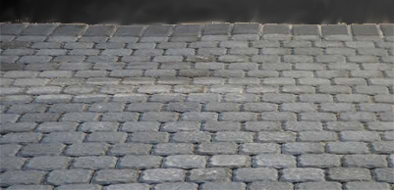
Figure 23: The Area's cobblestones, edged by a crosswalk border, with transition to asphalt at top.

(4.) Where a vehicular thoroughfare intersects with a crosswalk, the asphalt and/or concrete textures of its lanes shall cede to the cobblestone texture the crosswalk. In addition to the four crossings of each intersection, cobblestones shall extend across Halsey Street between the West Commons and the Arcade; across West Park Street, between the East Commons and the southern sidewalk; and across New Street, between the East Commons and the northern sidewalk. The width of the cobblestone pavement at each of these locations shall continue the width of the commons from which it extends.

(5.) Each curb shall be made of limestone. It shall have a chamfered or arced edge, facing outward, and the low point of its chamfer or arc shall rise six inches above the final grade of the thoroughfare pavement. The design of the curb shall create a gutter which collects rainwater and channels it to a storm sewer. Drain grates, whose surface area and specifications shall be determined by the appropriate standards of hydrology and engineering, shall be placed no less frequently than every 20 feet along the length of each gutter.

The following image illustrates the type of curb blocks that should be sought:

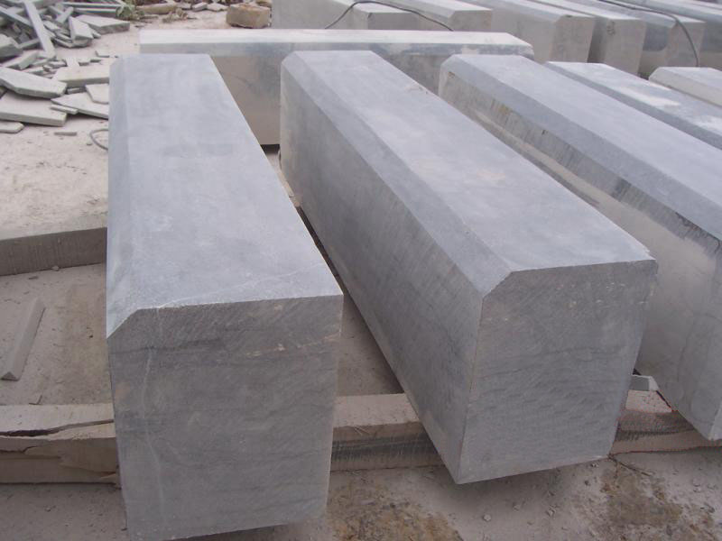
Figure 24: Blue limestone curb blocks, with chamfered outer edges.

(6.) Sidewalks shall be constructed of large blocks of bluestone slate, transitioning to the Area’s signature slate cobblestones in the four-to-five foot wide tree-planting strip along the curb. This transition adds a textural richness to sidewalks built from a single material; also, the pattern of smaller cobblestones may be more aesthetically interrupted by tree-plantings at regular intervals, than the larger blocks which comprise the main sidewalk.


Figure 25: Large blocks of bluestone slate, envisioned for the bulk of the sidewalks.

(7.) Utility lines shall be underground, and all manholes shall be located in the asphalt portion of the thoroughfare.

(8.) Where a sidewalk crosses a driveway, the texture of the sidewalk shall take precedence. Access through a sidewalk to any private driveway or parking garage shall be provided for with a dropped curb and sloped apron, and not by any interruption in the structure of the sidewalk itself. All driveways and curb cuts shall be narrowed to the minimum width necessary.

(c.) General Planting Requirements

(1.) All trees shall be a minimum of 3.5 inches in caliper measured at 6 inches from ground level and have a minimum branch height of 6 feet at time of planting. Street trees shall be spaced every 20-25’ along all streets and park edges, as indicated in the map below:

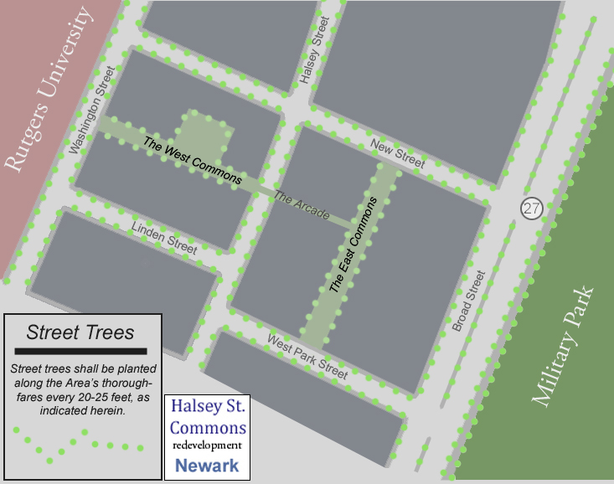
Figure 26: Locations of street trees along the Area’s thoroughfares, including the East and West Commons.

(2.) On every block, street trees shall be planted in a planting well, and their trunks shall be surrounded by ground cover, protected with decorative fencing no more than 18 inches high. Tree pits shall have minimum width dimensions of five feet from curb to sidewalk, and six feet lengthwise.

(3.) To protect trees, decorative grates around tree trunks are prohibited.

(4.) Trees shall be planted during the appropriate planting seasons, and all planting shall be carried out in compliance with the highest standards of arboriculture. In order to prevent future damage to surrounding infrastructure, appropriate root barriers shall be installed at the time of tree planting.

(5.) A schedule of recommended shade and flowering trees is provided below. No more than two varieties of trees shall be planted on a single block, and where two varieties are planted, they should be chosen to complement one another. This requirement shall not apply to the East Commons or West Commons.
Recommended Shade and Flowering Trees
Picture | Common Name | Species
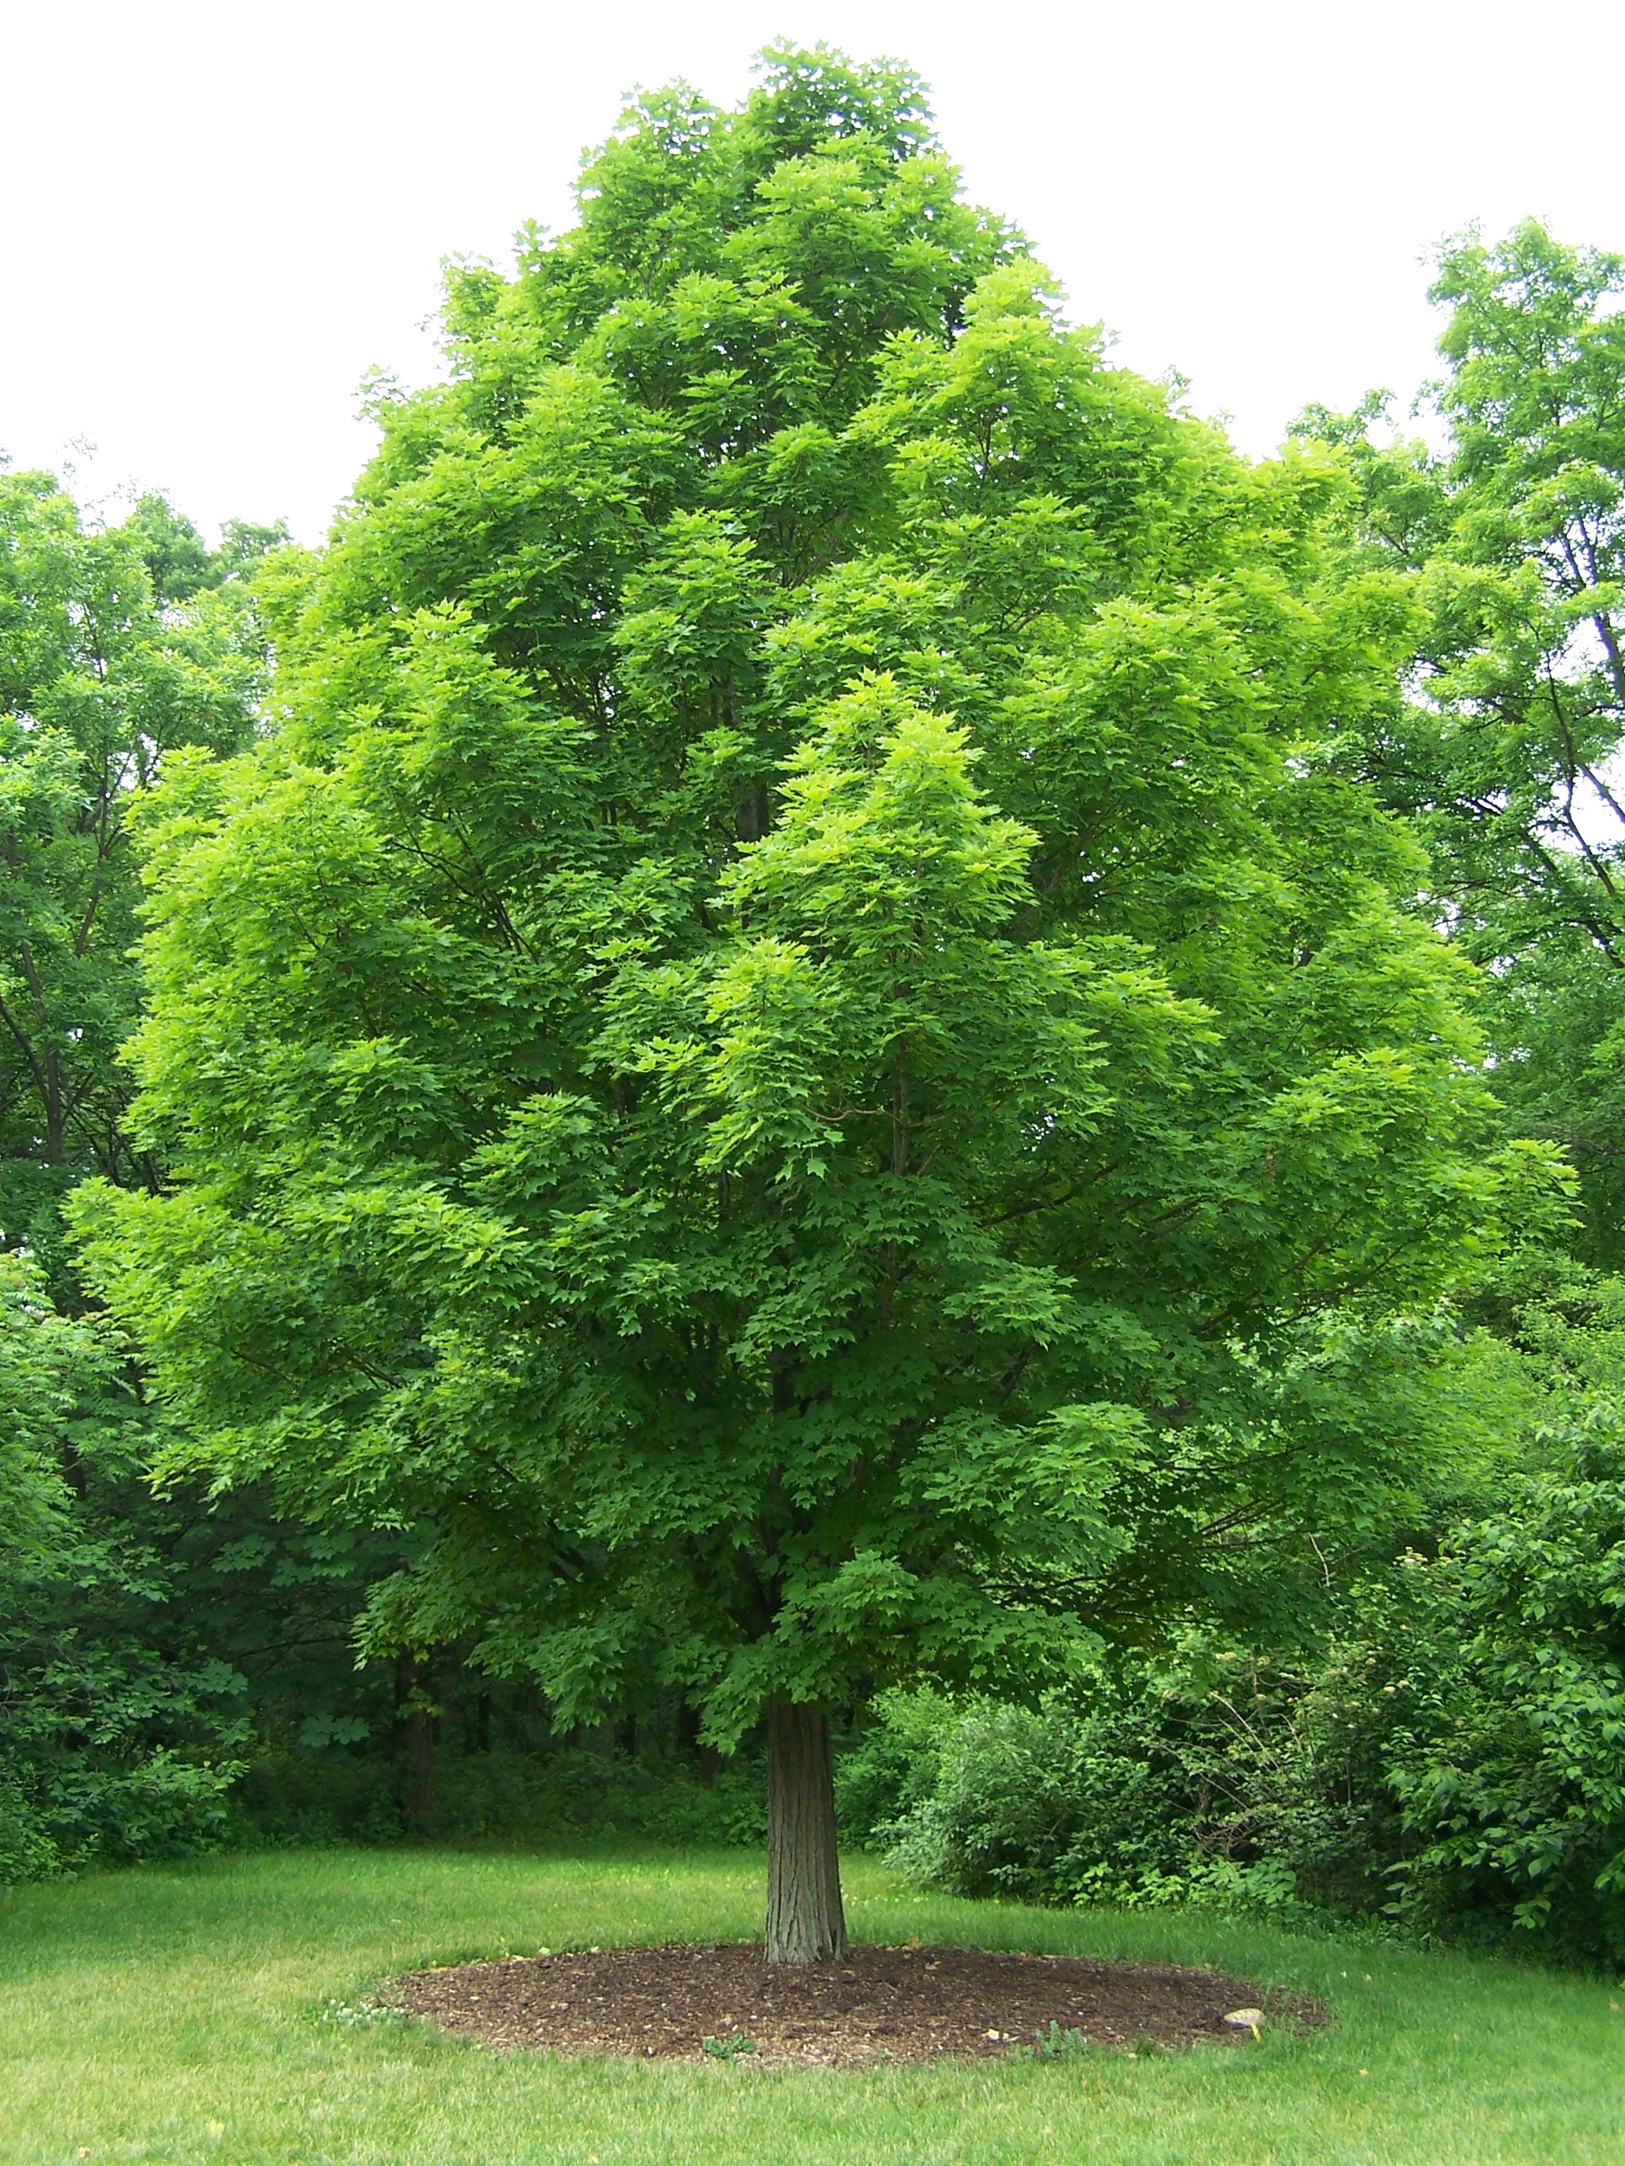 | Sugar Maple | Acer Saccahrum
 | Red Maple | Acer Rubrum
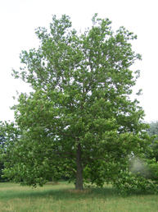 | Sycamore | Platanus occidentalis
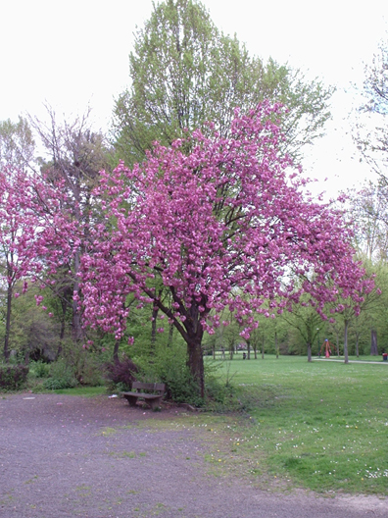 | Japanese Cherry | Prunus serrulata
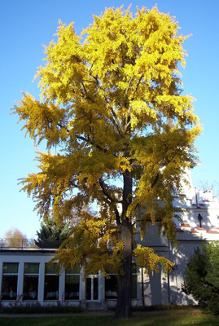 | Ginkgo | Ginkgo biloba
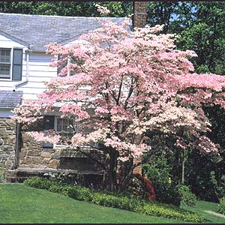 | Flowering Dogwood | Cornus florida
 | Eastern Red Bud | Cercis canadensis

(d.) Scent Design

(1.) Trees, flowers, shrubs, and grasses shall be chosen with careful consideration of their fragrances. Fragrances shall be consistent with the moods, effects, and general aesthetics of the Area, pursuant to the best approaches of scent design.

(e.) Outdoor Lighting Specifications

- All street lamps, park lamps, and traffic signals shall be installed and maintained with bulbs that comply with the 2010 standards of the International Dark-Sky Association. Additionally, bulbs shall be selected with consideration of their energy efficiency. More efficient lighting options shall be preferred.

- Street lamps and traffic signals shall be installed along the outer edge of the Area’s sidewalks, behind the curbs, and in line with the trunks of the street trees. Street lamps shall continuously alternate between the odd- and even-numbered sides of the street, and shall be located at in-line intervals of 60 feet, so that alternate-side lamps are spaced along the cartway at 30-foot intervals (conditions permitting). The first lamp in this sequence shall be located ten feet north or east of the curb radius of each intersection, on the odd-numbered side.

- All lamp posts and signal arms shall be of a high-quality, Victorian-style design, which complements the existing fabric of the neighborhood. Lamp posts and signal arms shall be manufactured of durable metal alloys, and painted either glossy black or matte dark green. All other qualities of the Area’s lamps shall be in keeping with the scale, permanence, and aesthetic of the Plan. A schedule of recommended lamps and signal arms is provided below.

- Park lamps shall be installed in the East Commons, the West Commons, and the Arcade. Additionally, park lamps shall be installed on sidewalks in line with, and in alternating sequence with, street lamps. Generally, there shall be a park lamp directly opposite every street lamp.

- Park lamps shall be of a high-quality, Victorian-style design, which complements the existing fabric of the neighborhood. Park lamps shall be manufactured of durable metal alloys, and painted glossy black. All other qualities of the Area’s park lamps shall be in keeping with the scale, permanence, and aesthetic of the Plan. A schedule of recommended lamps and signal arms is provided below.

- Wattage and lighting of street lamps and park lamps shall be adjusted to strike a harmonious balance between the provision of sufficient lighting to ensure safety and security, and a desire to avoid flooding the night-time streetscape with excessive glare. Where storefront display windows, including neon signs, and/or the entrance lighting of private apartment buildings and businesses can reliably contribute to a constant level of ambient street lighting, the wattage of adjacent street lamp and park lamp bulbs shall be reduced, accordingly.

- Retail display windows shall remain lighted until at least 11 p.m.

- Entrances to apartment houses shall remain lighted through the night. However, the intensity of apartment-entrance lighting may be reduced after 1 a.m.

- Entrances to businesses, including restaurants and bars, which remain open past 11 p.m. shall remain lighted until closing time.

(e.) Street Furniture Requirements

(1.) All street furniture shall be selected to express a consistent design vocabulary, in order to help establish a sense of aesthetic continuity throughout the Area. Street furniture shall complement the scale and architecture of the neighborhood, and the selections of lighting fixtures, paving materials, and plantings that help to comprise the surrounding streetscape.

(2.) Street furniture including wastebaskets, bicycle racks, and benches, which might present an obstruction to pedestrian traffic, shall be located along the outer edge of the sidewalk, behind the curb, to minimize such obstructions.

(3.) Merchants’ use of sidewalks in front of businesses should not hinder pedestrian traffic. However, sidewalk dining, craft sales, book sales, etc., are encouraged, and allowance for a pedestrian way having a width of at least six feet around an area of outdoor tables and/or displayed merchandise shall be presumed sufficient to avoid hindrance of pedestrian traffic, unless specific conditions indicate otherwise.

Recommended Lamps
Picture | Name | Description | Remarks
 | Lantern Arm with Acorn Globe | Simple, elegant; clean lines; raised arm; rounded glass. | Versatile, but ideal for wide streets and park frontages. This design was once common in Chicago and Los Angeles.
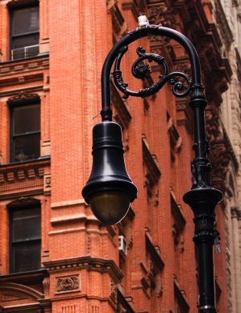 | Bishop’s Crook, with Acorn Globe | Detailing includes a flower & vine motif; acorn-shaped glass globe. | Compact size makes this lamp ideal for narrow streets with traditional buildings. Design has been common in New York City since the early 20th century.
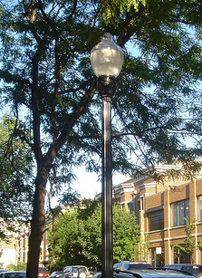 | Chicago Sidewalk & Park Lamp | Paintbrush design, with tapered glass globe. | Simple vertical post works well in parks and along sidewalks.
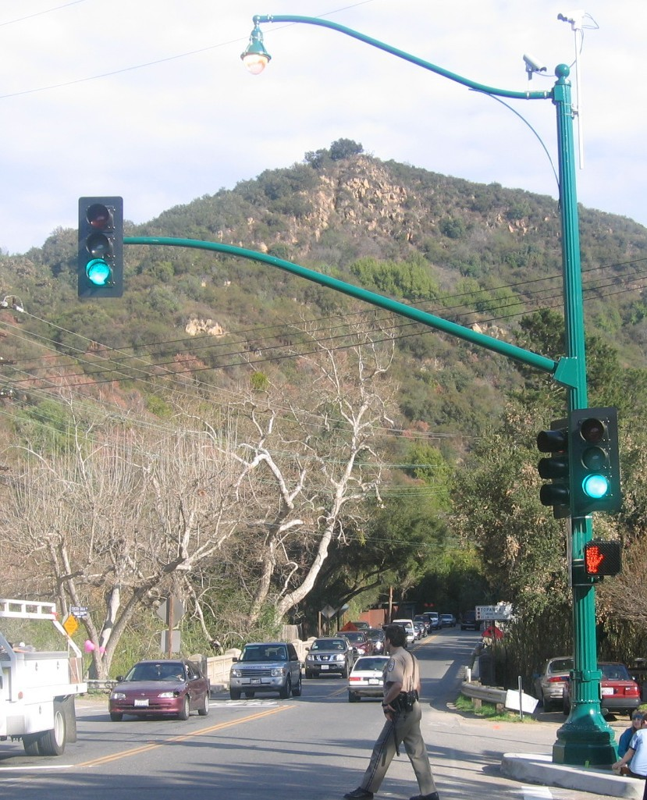 | Lantern Arm  with Signal | Very similar to the first lamp, but with an added signal arm that echoes the same lamp’s design. | Timeless design is appropriate for most intersections; design was once common in Los Angeles.
(f.) The Commons and Arcade

As with the Radburn model, this Plan envisions a walkable community with a distinctly pedestrian realm. This realm exists at arm’s length from the realm of motor vehicles, and in shared spaces, it is distinguished by its generously proportioned sidewalks, its buffer zones of trees and other plantings, its signature crosswalks, its landscaping of semi-public edges, and its consistent vocabulary of high-quality, permanent, and complementary street furniture. In addition to these largely-aesthetic features, a series of traffic-calming measures have been designed into the Plan, as have lamps and geometric design details which will improve the pedestrian experience throughout the Area.

In addition to defining the pedestrian realm in shared spaces, a series of exclusively-pedestrian spaces is envisioned. Two distinct pedestrian malls, joined by an arced procession through interceding buildings, are provided for in the land use portions of this plan. These spaces, which extend through the geographic heart of the Area, shall be known as the East Commons, the West Commons, and the Arcade, respectively. Throughout these spaces, the following regulations shall apply:

- All walkways shall be paved with the Area’s signature cobblestones.

- A fountain shall be constructed in the West Commons, at approximately the point at which it is indicated on the Commons & Arcade Map. The fountain shall have a diameter of at least 30 feet, and shall be designed in a manner that is consistent with the overall aesthetic and detail of the Plan.

- Planters shall be placed every twenty feet, with colorful flowers, during the spring, summer, and fall, in locations roughly as indicated on the Commons & Arcade Map.

- During the first ten years following adoption of the Plan, the ground-floor retail space at the northwest corner of the West Commons shall be leased to a book store or substantially similar establishment.

- During the first ten years following adoption of the Plan, the ground-floor retail space at the southwest corner of the West Commons shall be reserved for a grocery store, supermarket, natural foods store, or substantially similar establishment.

- An open-air Arcade shall be constructed through the buildings on the east side of Halsey Street, joining the West Commons with the East Commons. The arcs of the Arcade shall be between 16 and 24 feet high, and shall be spaced at intervals of between eight and twelve feet. The Arcade shall be lighted through the night, and fitted with security cameras. Entrances to the apartment buildings shall be located along the walls of the Arcade. A deli and/or newsstand may also be established here.

- There shall be no street lamps in the Commons or Arcade. Instead, the East and West Commons shall be lighted by park lamps, as described above, and the Arcade shall be lighted in a design consistent with that of grand entrances and arcades, and with the overall aesthetic, detail, and scale of the Plan.

- Bollards shall be placed where the Commons adjoin regular thoroughfares. These shall be retractable to allow for deliveries at specified times, and to permit access for emergency vehicles, when necessary. Under normal circumstances, no motor vehicles shall be permitted to operate in the Commons or the Arcade.

- The following Commons & Arcade Map shall serve as guidance for development of these spaces:

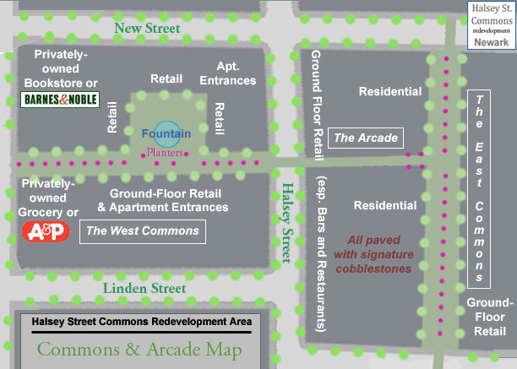
Figure 27: Concept map of the Commons & Arcade, showing mixture of uses, and priority retail.

VII: Parking and Utilities Plan

 | Retained Existing  Space | Proposed  Space – New Construction | Proposed Area Total | No. of  Parking Spaces
Residential | 139,619 | 833,315 | 972,934 | 1189
Office | 46,539 | 277,772 | 324,311 | 324
Retail | 63,120 | 97,164 | 160,284 | 160

(a.) Formulas Used

The Area’s parking needs were determined by applying the following formulas:

1. Residential. 1.1 spaces per unit.
2. Office Space and Retail. One parking space to every 1,000 sq ft.

This set of formulas yields a significantly lower parking demand projection than what most suburban models would predict. Standard greenfields development approaches provide for between two and five parking spaces for every 1,000 sq ft of commercial space, and often at least two vehicles for every single-family housing unit.

Due to the Area’s intense, nearby infrastructure of mass transportation, as well as its envisioned walkability, the Plan presumes to apply a formula that predicts a significantly lower rate of car dependence than what might be expected in a suburban location. In short, the Plan accepts as fact that high-density, urban development will generate fewer car trips, and lesser demand for parking, than an equal amount of economic development might produce in a suburban setting. In doing so, it revises its formulas accordingly.

(b.) Parking Demand

Our formula predicts a demand for about 1,675 parking spaces for the Area. The Plan provides for this demand with a combination of embedded and underground parking structures, as well as on-street, metered parking.

In general, a structured parking space, including its share of building infrastructure (driving lanes, structural columns, elevator shafts, stairwells, gates for ingress and egress, etc.) requires about 270 square feet, yielding an Area-wide demand of 451,710 square feet of structured parking. But this demand can be divided among multiple levels, reducing the area occupied by all parking spaces to a much smaller overall footprint. Conversely, an on-street parking scheme requires just about 200 square feet of space per car. However, since the land use efficiency of street spaces cannot be maximized with multiple levels, our parking demands would require 335,000 square feet of raw land to be accommodated through metered surface parking. Clearly, providing for more than a small portion of the Area’s parking demand with on-street spaces would entail prohibitive demands being placed on the Area’s available space, as well as its overall design quality.

(c.) Parking Structures

The Plan shall provide for the bulk of the Area’s parking demand with the construction of two new parking structures. Together, these high-capacity facilities will accommodate the parking needs of at least 1,550 vehicles, or approximately 92 percent of the Area’s projected demand. Design shall ensure that neither structure shall be visible from the street, except at the required number of gates of ingress and egress. In addition, the following specifications shall apply to the construction of these structures:

- The South structure shall be constructed beneath and within a new mixed-use project that will face Military Park, occupying the bulk of the Broad Street block between West Park and New Streets. This parking structure shall accommodate approximately 895 vehicles. The underground levels shall have approximately 118,000 square feet of parking, and at least 435 spaces; while the embedded levels shall provide approximately 126,000 square feet of parking, and at least 460 spaces.

- The North structure shall be constructed beneath and within the adaptive reuse of the historic Hahne & Co. façade, occupying the northwest corner of Broad and New Streets. This parking structure shall accommodate approximately 655 vehicles. The underground levels shall have approximately 94,000 square feet of parking, and at least 340 spaces; while the embedded levels shall provide approximately 85,000 square feet of parking, and at least 315 spaces.

- Each of the two structures shall consist of two levels of underground parking, and five levels of embedded parking.

- The underground portions of the parking structure shall be designed to occupy the maximum plausible percentage of the above-building’s footprint, consistent with good engineering and architectural practices, to maximize the number of vehicles which it may accommodate.

- The embedded portions of the structure shall be designed to occupy the entire courtyard area of the building, between the ground level and the fifth floor.

- The embedded portion of the structure shall be designed to occupy the entire portion of building which lies on the internal side of any central corridors, between the ground and the fifth floor.
- Each level of parking shall have a height clearance of at least eight feet, to accommodate typical vehicles. The ground level shall have a height clearance of at least 11 feet, to accommodate service vehicles.

- Parking spaces shall have minimum dimensions of nine by18 feet, and structure aisles shall be between 22 and 24 feet wide, to safely allow for two-way traffic.

- Each structure shall be topped with a green roof, which shall serve as an enclosed common courtyard and/or deeded patio space, with direct access to the sixth floor units which border such space. Such space will also facilitate the construction of overlooking terraces on floors seven through ten, either with or without direct physical access to the green roof.

- This design shall ensure sufficient parking for the Area, while eliminating the potential development of substandard units, which would lack sufficient sunlight and fresh air, along the depths of what would otherwise be an open courtyard; while providing for improved aesthetics for potentially sunnier, airier units in the same locations on higher floors.

- Parking structures shall have direct access by elevator and stairs to a sidewalk. In addition, the South structure shall have direct, pedestrian access to the open East Commons, through a walkway that passes through the interceding buildings; and shall also have direct access to those buildings, either through the same or another walkway. The North structure shall have direct, pedestrian access to the northern sidewalk on New Street, which shall be located directly opposite the northern entrance to the East Commons.

- The South structure shall have a gate on Broad Street, which shall service the northern half of its spaces, and a second gate on West Park Street, which shall service the southern half of its spaces. The North structure shall have a gate on New Street, which services all of its spaces.

- Monthly and annual flat-rate use permits shall be available to all residents of the Area, and certain portions of the structures, not exceeding an overall share of 1.1 spaces to each built unit, may be reserved for such subscribers.

- Hourly and daily parking rates shall be available for all other users.

- An attendant shall be on duty at each point of ingress/egress at all times.

- Together, the two garages shall provide for approximately 423,000 square feet of parking, with a total of at least 1,550 spaces.

(d.) Metered Street Parking

The remainder of demand, some 125 spaces, as well as some additional parking spaces, will be provided for with metered parking along Broad and Washington Streets. During business hours, the Area’s on-street parking shall be time-limited, in order to facilitate regular vehicle turnover, and ensure the availability of convenient on-street parking spaces for motorists who wish to run short errands in the Area.

The following map shows the locations and capacities of both garages, as well as on-street, metered parking areas:

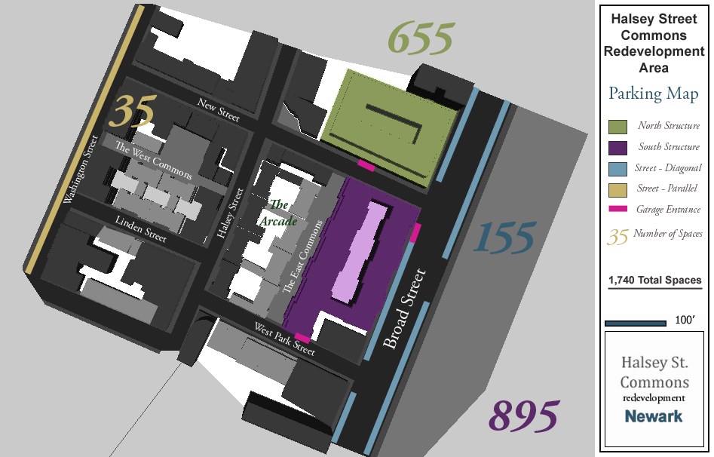

(e.) Additional Parking Requirements

- Bicycle parking shall be provided throughout the Area, with at least two public bicycle racks per block. Each rack shall have the capacity to accommodate at least twelve bicycles. In addition to block-by-block requirements, bicycle racks shall be maintained at appropriate locations in the East Commons, the West Commons, and adjacent to Military Park, Rutgers University, and the Arcade.
- The Plan endorses the development of remote parking locations, located near public transportation, at a greater distance from downtown Newark. The Plan sees remote parking as a way of reducing the numbers of vehicles which must be routinely stored within the Area. In order to facilitate broader use of remote parking, the Plan encourages the addition of late-night service along any public transportation routes that serve such remote parking facilities.
- The elements of the parking plan may be reconsidered, with public comment, and review and approval by the Planning Board.

(f.) General Utility Requirements

All proposals for new structures, lines, equipment, facilities, and other instrumentalities pertaining to public utilities, water, and sewerage, shall be subject to review and approval by the appropriate city and state agencies. In addition to such requirements, the following standards shall be met by any proposal for the Area:

- All lines and service connections to individual buildings or units, as well as all transmission lines, transformers, and signal boxes, shall be located underground.

- No proposed development in the Area shall be approved until all necessary wastewater piping plans for the removal of effluent and storm water have been filed and approved by the City Engineer, and all municipal facilities which will bear the burden of the new development have been certified by the Planning Board, the Division of Engineering, and the Municipal Utilities Authority as being of sufficient capacity and good condition to accommodate the proposed new capacity. Such approval may become contingent upon the funding of requisite improvements to the existing system, as deemed necessary by the Planning Board, Division of Engineering, and Municipal Utilities Authority.

- With the exception of storm water collection and channeling schemes, all utilities shall be placed under the streets, and access shall be through manholes located in the asphalt portion of the thoroughfare.

VIII: Legal Provisions
(a.) Legal Requirements

- Validity of the Plan. If any section, subsection, paragraph, division, subdivision, clause, or provision of the Plan should be held invalid by a court of appropriate jurisdiction, such holding shall only apply to the particular section, subsection, paragraph, clause, or provision in question, and the remainder of the Plan shall remain valid and in effect.

- Zoning Map Revisions. The Zoning Map is amended by the Plan, and shall be revised to reflect the Plan’s provisions, and to show the boundaries established for the Area, within which all such provisions shall apply.

- Plan Supersedes Existing Ordinances. The Plan supersedes all existing provisions of the Zoning Ordinance which apply to the Area, and which are specifically addressed by the Plan. The Plan supersedes all provisions of the Municipal Code which apply to the Area, and which are specifically addressed by the Plan. Any zoning issue that is not addressed by the Plan shall be clarified by reference to the Zoning Ordinance.

- Variances. The Planning Board shall have the sole authority to grant variances from the requirements of the Plan, according to the appropriate provisions, infra.

- Nonconforming Uses. Upon revision of the Zoning Map and amendment of the Zoning Ordinance, parcels whose primary use or structure is inconsistent with such map and/or ordinance shall become nonconforming uses.

- Parcelization. In the event of parcelization, nothing in the Plan shall preclude the partial redevelopment of a block, as depicted in the Plan, provided that such redevelopment is fully in conformance with the written standards, diagrams, and regulations contained herein.

- Approval of Parcelization. Parcelization shall be subject to approval by the Planning Board, and shall be reflected within the appropriate Redeveloper Agreements, as may be executed between the Redevelopment Entity and such Redeveloper(s) as may be designated by the Redevelopment Entity.

- Amendments.

  - As development occurs within the Area, development priorities and market demands may change. This Plan shall be adaptable to meet the changing needs of the local market, the City of Newark, and its citizens. Amendments may be required in order to accommodate these changes.

  - The Plan may be amended from time to time, in accordance with the requirements of the law. Any amendment to the Plan shall be made by ordinance, as formally adopted by the Municipal Council, after public comment and hearing. Prior to such action by the City Council, the proposed amendment(s) shall be referred to the Municipal Planning Board for review and recommendation, pursuant to the provisions of N.J.S.A. 40:12A-7.

  - Any amendment(s) to the Plan shall include a Plan Consistency Review, which examines any changes in relationships between the amended Plan and other applicable documents, including the Master Plan of the City of Newark, the master plans of adjacent municipalities, the Essex County Master Plan, and State Development and Redevelopment Plan.

  - Any amendment(s) to the Plan should abide by the street locations and typologies set forth by this Plan, regardless of intended future use.

- Minor Variations in Site Plan Design. During review, the Municipal Planning Board may approve minor modifications to the written standards for site plans, in the interest of project implementation and in furtherance of this Plan and the standards set forth herein. However, minor modifications to standards which are specific and mandatory, including allocations of uses, placement of build-to lines, building heights, structural massing, architectural standards, and landscaping standards, may be approved only by the Municipal Planning Board through the formal grant of a deviation, as provided, infra.

- Deviations.

- The Municipal Planning Board may grant formal deviations from the regulations contained within this Plan, where, by reason of exceptional narrowness, shallowness, or shape of a specific parcel, or by reason of exceptional topographic conditions, pre-existing structures or physical features uniquely affecting a specific parcel, the strict application of any specific objective or regulation adopted pursuant to this Plan would result in peculiar and exceptional practical difficulties to, or exceptional and undue hardship upon, the Redeveloper of such property; and where such exceptions do not contradict the essential goals and objectives, or design and aesthetic standards, of the Plan.

- The Municipal Planning Board may also grant a deviation from the regulations contained within this Plan related to a specific piece of property where the purposes of this Plan would be advanced by such deviation; and where the benefits of granting such a deviation would outweigh any detriments.

- The Municipal Planning Board shall have exclusive authority to grant exceptions or waivers from the Plan’s architectural, landscape, or other design standards, as may be reasonable and within the general purpose and intent of the of this Plan, if the literal enforcement of one or more provisions of the Plan is impracticable, or would exact undue hardship upon a Redeveloper because of peculiar conditions of to the site.

- No deviations shall be granted under the terms of this section unless such deviations do not result in substantial detriment to the public good, and such deviations will not substantially impair the intent and purpose of the Plan.

- Deviations shall not be granted which permit:

- The use of a parcel in a manner inconsistent with the use to which it has been specifically assigned;
- The use of a parcel in a manner which has the potential to create a nuisance for the uses to which adjacent parcels have been assigned;
- Any expansion of a non-conforming use;
- Any increase in the allowable height of a structure which exceeds by 15 feet, 10 percent, or more than one story, whichever is least, the height required for the parcel;
- A decrease in the allowable height of a structure which exceeds by 15 feet, ten percent, or more than one story, whichever is least, the height required for the parcel;
- A change in the placement of the build-to lines for a parcel, which results in a disruption to the proposed continuity of a particular blockface;
- A change in the stepback requirements, which results in the disruption of a defined cornice line, or the visibility of a tower from vantage points at which it would otherwise be obscured; or
- A significant change in the allowable density of a parcel.

- A Redeveloper who requests a deviation from the requirements of this Plan shall provide public notice in accordance with the requirements set forth in NJSA 40:55D-12.a. & b.

- Plan Consistency Review. Several urban renewal and redevelopment plans cover portions of downtown Newark, a number of which share borders with the Halsey Street Commons Redevelopment Plan. These plans remain in effect and continue to guide development of those locations, except where they overlap with the Halsey Street Commons Redevelopment Plan. In those instances, the Halsey Street Commons Redevelopment Plan supersedes. The plans to which this applies are the following:

- The Newark Living Downtown Redevelopment Plan

- The Newark Arts and Education Urban Renewal Plan

- The Newark Colleges Urban Renewal Plan

- The Broad Street Station District Redevelopment Plan

- The James Street Commons Historic District Project Area Plan

- The Downtown Entertainment District Plan

- The City of Newark Master Plan. The Plan complements and furthers the goals of the Land Use Element of the Newark Master Plan, which designates all of the Area as part of its Special Downtown Land Use District. This area is encouraged to become a high-intensity, mixed use district, which includes an entertainment overlay. Intense office use and high density residential are permitted, while retail development is emphasized. The Halsey Street Commons Redevelopment Plan’s design principles, which focus on new residential development and a strong retail element, with designated retail streets, is congruent with the goals of the Special Downtown Land Use District of the Land Use Element of Newark’s Master Plan.

- State Development and Redevelopment Plan. The goals and objectives of the Plan are broadly consistent with the State Development and Redevelopment Plan. Newark is a designated an Urban Center in the State Plan, where intense land development is encouraged, and such intensity is especially promoted within the CBD. A primary goal of the Plan is to transform downtown Newark into a 24-hour, mixed use environment, is broadly consistent with the goals of the SDRP.

- Other Municipalities. The Area has no common boundary with any other municipality, and it would not have a significant impact on the plans of any municipality which borders the City of Newark.

(b.) Project Master Plans

- At the start of the review process, each Redeveloper shall submit a project master plan to the Municipal Planning Board, which shall identify its specific project, and its proposed site within the Area.

- Each project master plan shall describe the Redeveloper’s proposals for structural massing, building elevations, floor plans, plazas and open spaces, streetscape and landscape improvements, semi-public edge treatments, as well as a schedule of proposed uses, in accordance with the Plan.

- Each project master plan shall include a complete site plan for its parcel(s), as described in detail in the Landscape Plan, supra. If not included within its primary diagram, utility infrastructure specifications shall be attached to the site plan.

- The Municipal Planning Board shall review each project master plan. In order to proceed to approval, the Municipal Planning Board must find in its review that the project proposal satisfies each of the specific requirements, including form-based standards and land use requirements, of the Plan; and each of the broader goals and objectives of the Plan.

- The Municipal Planning Board must find that the proposal is consistent with the general aesthetic goals of the Plan in its totality

(c.) Implementation of Redevelopment Plan

- By resolution of the Municipal Council, a Redevelopment Plan has been adopted for the Area, under the provisions of N.J.S.A. 40A:12A-7.

- Pursuant to the provisions of a Redevelopment Plan which is adopted under N.J.S.A. 40A:12A-7, a municipality or redevelopment entity may proceed with clearance, re-planning, conservation, development, redevelopment and rehabilitation of an area in need of redevelopment.

- With respect to a redevelopment project, the municipality or redevelopment entity, upon the adoption of a redevelopment plan for the Area, may perform any of the actions set forth under N.J.S.A. 40A:12A-8.

(d.) Redevelopment Agreements

All projects in the Area shall be undertaken pursuant to appropriate redevelopment agreements, between the Redeveloper(s) and the contractor(s). Such agreements shall be drafted for each separate project, and shall be approved by the Redevelopment Entity, as designated by the Municipal Planning Board. Agreements shall not be required in cases of de minimis projects, for which they would be redundant or unnecessary.

(e.) Preliminary Design Review

- Prior to the submission of a project master plan to the Municipal Planning Board for review and approval, descriptions of all proposed projects in the Area shall be submitted to the Municipal Planning Board, its designated staff, or its designated design review professionals for preliminary design review, in order to ensure the proposal’s compliance with the design requirements of the Plan.

- Following submission of such descriptions for review, Redevelopers shall consult with the Municipal Planning Board, its designated staff, or its designated design review professionals, at a scheduled meeting, in order to discuss their proposal(s).

- The preliminary design review process shall focus on such elements of the proposal(s) as building heights, structural massing, architectural standards, planting and other landscaping standards, and provisions made for open space.

- Prior to the approval of the redevelopment project by the Planning Board, the design review professionals shall provide their findings and recommendations regarding the proposal to the Municipal Planning Board. Such findings and recommendations shall discuss the extent to which the proposed project is consistent with the Plan.

(f.) Planning Board Review

- Pursuant to the requirements outlined in N.J.S.A. 40A12A-13, all applications for development of parcels in the Area shall be submitted to the Municipal Planning Board for review and approval. The following provisions shall apply to the review process for proposed projects in the Area:

- Prior to commencement of: (a) any construction; (b) reconstruction; (c) rehabilitation; or (d) any change in the use of any structure or parcel, a project master plan, including a site plan as outlined in the Landscape Plan section, shall be submitted by the Redeveloper to the Municipal Planning Board for review and approval. No temporary or permanent Building Permit shall be issued for any work associated with (a). through (d). above, without review and approval of the entire project master plan by the Municipal Planning Board.

- The Municipal Planning Board shall conduct project plan review, including site plan review, if applicable, pursuant to N.J.S.A. 40:55d-1 et seq. and the Newark Municipal Land Development Ordinance.

- As a prerequisite to project plan approval, the Municipal Planning Board’s review must find that each of its proposals are in full compliance with each of the applicable requirements enunciated by the Plan. Further, each of its proposals must be found to be consistent with the goals and objectives, and the general aesthetic requirements, of the Plan.

- As a prerequisite to project plan approval, the Planning Board may require the Redeveloper to furnish reasonable performance guarantees for various street improvements and utility improvements, pursuant to N.J.S.A. 40:55D-53. The performance guarantees shall be written favorably toward the City, and the Newark City Engineer shall determine the appropriate amounts of any such performance guarantees.

- Any subdivision or assembly of lots or other land parcels within the Area shall be conducted in compliance with the specifications of the Plan, and shall be reviewed for such compliance by the Municipal Planning Board, pursuant to the provisions of N.J.S.A. 40:55D-1 et seq.

- A property that has been redeveloped in accordance with the Plan may not be converted to any use other that those which are expressly assigned for such property by the Plan.

- In the event of its destruction, a parcel constituting a nonconforming use under the Plan may not be rebuilt to facilitate such use again, provided that its destruction did not result from an intentional, malicious act. For the purposes of this subsection, the Municipal Planning Board, through the use of reasonable criteria, shall determine whether a nonconforming parcel or use has been destroyed.

- Variances, waivers, and deviations which would permit a use which is expressly prohibited by the Plan shall not be issued.

- The regulations and controls of the Plan shall be implemented, where applicable, by appropriate covenants, servitudes, agreements, or other instruments, or through provisions for land conveyance and/or disposition between the Redeveloper and municipality. This section shall be carried out pursuant to the provisions of N.J.S.A. 40A:12A-8 and 40A:12A-9.

- For the purposes of the Plan, definitions contained within the Defined Terms, supra, shall prevail. In the absence of a definition, definitions contained within the Defined Terms of the Newark Municipal Land Development Ordinance shall prevail. Definitions which are inconsistent with the provisions of N.J.S.A. 40A:12-3 shall not be valid.

- The Redeveloper shall pay all applicable escrow fees, and other required charges, in accordance with applicable provisions of the Newark Municipal Land Development Ordinance, and other applicable laws of New Jersey and the United States of America.

- Naturally, the provisions of the Plan are subject to resolution in the appropriate Courts of law and equity, according to their respective interpretations of the prevailing laws of New Jersey and the United States of America.

(g.) Non-Discrimination Provision

No covenant, lease, conveyance, or other instrument shall be executed by the Municipal Council of Newark, any Redeveloper, or any successors or assigns thereto, under which the use or occupancy of any land, structures, or fixities within the Area shall be restricted to persons on the basis of their race, creed, color, nativity, sex, or sexuality.

(h.) Affordable Housing

25 percent of all new residential units in the Area shall be affordable, consistent with the interpretation affordable housing under the Mount Laurel doctrine. The distribution of affordable housing units by size shall be determined on a pro rata basis, based on the overall proportion of different unit sizes.

IX: Acknowledgements

The basic structure of this Plan, as well as some of its technical legal language, draws on the statutory language of the Bayfront I Jersey City Redevelopment Plan. Meanwhile, the Broad Street Station Area Redevelopment Plan and the Newark Living Downtown Redevelopment Plan were also influential in the drafting of this plan. Finally, Google Maps, and the Newark Geographic Information Network, were tapped as sources for the Plan’s cartography.

